**Combined Heat and Power Systems: Always Suitable? The Portuguese Case**

Clito Afonso1,* and Tiago Moutinho2

1 Universidade do Porto, Faculdade de Engenharia, Depart. Engª Mecânica - Porto, Portugal

2 Auditene, Rua Brito Capelo, nº825, 4450-076. Matosinhos, Portugal

*\*Corresponding email: clito@fe.up.pt*

ABSTRACT

The energy markets are currently under tremendous pressure caused by instability in fuel prices and environmental issues. The citizens are affected by the constant increase in fuel prices, threat to the security of energy supply and by climate change resulting from an environmental policy neglected

So, cogeneration systems arise as a way of producing high efficiency energy, lower environmental impacts, and a decrease in the consumption of primary energy. However, cogeneration, to date recognized as one of the most efficient ways of producing electricity and thermal energy, has seen its future in jeopardy because of the recent austerity policies which have decreased the remuneration regarding the electricity produced.

The objective of this work is the approach to the new legal framework applicable to the cogeneration activity in Portugal. In that way, an energy audit was done based on an existing cogeneration plant. A comparison of the results obtained by applying the new legal framework with the results obtained by previous legislation was carried out. The avoided CO2 emissions were compared with separate heat and electricity production. A sensitive economic analysis was carried out in function of the prices of electricity, fuel and cost investment.

KEYWORDS: Cogeneration, NPV, IRR, PES, Energy Audit.

1. INTRODUCTION

Energy is an indispensable factor for any human activity. Transport, industrial production, trade, communications, etc. depends on the energy availabity. The generation, rational and efficient use of energy in a way influence the actual society, either for economic reasons (competitiveness), either for the environmental impact due to its use.

However, the satisfaction of our energy needs has been made mostly at the expense of conventional energy such as oil, coal and natural gas. Although, present in large-scale in the planet, they are not renewable on a human scale, bringing negative consequences to the environment. This leads to a new concept, called sustainable development (rational use of energy and energy needs) that emerges to try to reduce this issue.

Traditionally, consumers satisfy their energy demand by purchasing separately electricity and fuel from distribution companies. Regarding the electricity acquired by consumers, much is produced in thermal power plants. In most modern plants operating in combined cycle the efficiency is about 52.5 %. If it is taken into account the losses inherent in the transportation of electricity, the figure becomes 48.5 %. So it can be seen that over 50 % of the energy used to generate electricity in large power plants power is inevitably lost to the environment, without the possibility of practical use.

The power generation of thermal energy produced from fuels purchased by consumers is obtained in burning systems which average efficiency is, at best, about 90 % (referred to the lower calorific value of the fuel). From the foregoing it can be seen once again that at least about 10% of the fuel energy used to generate heat is also lost to the environment without the possibility of practical use.

Given these issues, arises the need to increase the efficiency of production processes for electricity and heat generation in order to reduce the financial and environmental costs.

Thus, as an alternative to large power plants and distribution networks of high voltage emerges the decentralized production of electricity, and in particular the Combined Heat and Power (CHP) or Cogeneration, in order to take advantage of the inherent limitations on the conversion of heat into work [1-3]. Through a succinct definition, CHP is a process of exploration and production of combined heat and power, in an integrated system, from the same primary source, Fig. 1. The use of the same primary energy source to generate electricity and heat simultaneously results in high levels of savings and hence a very significant reduction of the energy bill without changing the production process of the consumer.

In this work a case study of a CHP facility in Portugal was carried out with a detailed analysis of NVP, IRR and PES and how the fluctuations of the prices of electricity, fuel and cost investment influences these factors. Also a study was done regarding the avoided CO2 emissions of the CHP.

Energy audits to carry out to cogeneration installations depend on the date of obtaining the license, therefore of which laws have to be checked. If the CHP has been licensed before the entry into force of the current legislative framework, is aimed to comply with the provisions of Article 23 of Decree-Law n. 538/99 of December 13, as amended by Decree-Law Nº 313/2001, of 10 December. If the cogeneration plant has been licensed under the current legislative framework, it will have to verify the conditions set out in Decree-Law No 23/2010 of 10 December, taking into account the recommendations contained in the Manual of Procedures EEGO (Entity Issuer of Guarantees of Origin).

The facility to be analyzed has been initially licensed under Decree-Law No. 538/99, and is currently in a transitional phase for the new legal framework established by Decree-Law No 23/2010.

In this way, it will be checked regarding the conditions imposed by the previous legislation (EEE≥0.55) checked in relation to its integration in the new legislation (PES>10%).

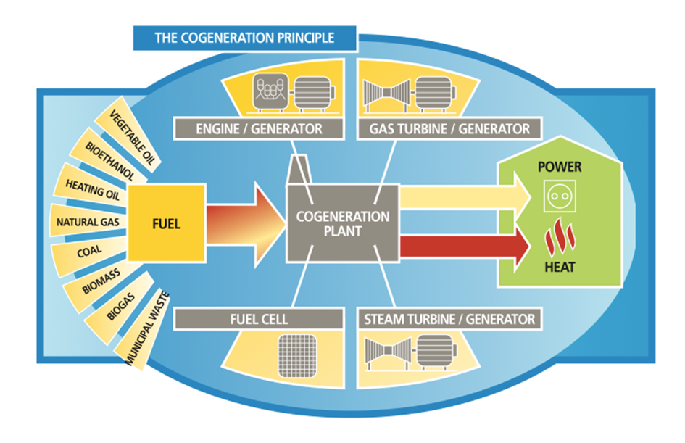

Fig. 1 The cogeneration principle [4].

**2 THE COGENARATION FACILTY**

It was performed an energy audit into a Portuguese company that owns a cogeneration facility. This cogeneration plant consists basically of an alternative engine working on Otto cycle running with natural gas (ROLLS-ROYCE KVGS16G4) with an electrical output of 3220 kWe. It was connected to a recovery boiler for the production of saturated steam at 11 bar. The engine is coupled to an alternator for the production of electricity at 4025 kVA. The exhaust gases of the engine, after undergoing the recovery boiler are sent to the atmosphere through a chimney. Part of the thermal energy contained in the cooling water circuit of the engine is also recovered in the form of hot water for supplying the productive process of the factory.

The facility was monitored with measuring devises located in several points, namely:

• Fuel: gas meter outside the facility, mounted on the regulating and metering station;

• Steam produced: flowmeter installed in the feed pipe of the manifold;

• Hot water (cooling water circuit of the engine): flowmeter mounted in the heat pipe connection (forward and return) to the heat exchanger;

• Electricity sold: energy meter mounted after the transformer, in the interconnection with the national grid;

• Temperature and pressure: sensors located in the most important points of the facily.

* 1. **PARAMETERS to be EVALUATED**

In a cogeneration facility there are several parameters that must be evaluated, namely:

• Electrical efficiency, electrical:

ηelectrical = Egross elctricity /Total fuel consumed

• Thermal efficiency, thermal:

ηthermal = Egross thermal /Total fuel consumed

• Global efficiency of the system, global:

• Primary Energy Savings, PES.

In the context of Decree-Law No. 23/2010, of 25 March, [5], the promotion of high-efficiency cogeneration based on a useful heat demand is a priority. This is due to its potential for saving primary energy and, consequently, reduction of CO2 emissions. It is also related with the significant decrease in network losses associated with decentralization of electricity production as well as to the potential contribution to security of supply. For the purposes the same decree law, the PES of the cogeneration activity when compared with separate production of heat and electricity is calculated according to the following formula:

The absolute value of PES of cogeneration activity is determined by the following equation:

where and are respectively the reference values for harmonized efficiency for separate heat production and for separate electricity production. They are influenced by a correction on the average climatic conditions (Annex III) and a factor concerning network losses (Annex IV) of Directive 2004/8/EC, [6]; HCHP is the useful thermal energy produced, Etotal is the total electrical energy produced and Ftotal is the consumed fuel.

• Equivalent electrical efficiency of the facility, EEE:

For the evaluation of these mandatory parameters, it is previously necessary to calculate the following ones:

• Useful electricity, *Eu*;

• Thermal energy of the steam to the process, *QV*:

where Mv and Hv are respectively the vapour consumption and enthalpy

• Thermal energy in hot water of the engine cooling system, *QAQ*;

• Thermal energy of the feed water to the boiler, *QA*:

where Ma and Ha are respectively the water consumption and enthalpy.

• Thermal energy of natural gas, *QGN*:

where VGN and PCIGN are respectively the natural gas consumption and lower heating value.

* 1. **RESULTS of SURVEY and NEW MEASUREMENTS**

In the year 2012 an audit was done to the cogeneration facility (annual historic – January to December), based on the measured values obtained with the instrumentation already installed in the system (as stated earlier). In the year 2013 (March) a new visit was done, where more sensors were installed. All the parameters described in section 2.1 were evaluated. Table 1 summarizes the main ones.

Table 1 - Comparison of the main results obtained in the survey and the measured ones.

|  |  |  |
| --- | --- | --- |
| Parameters | Audit | Measurements |
| Electrical efficiency, net % | 35.7 | 40.0 |
| Thermal efficiency % | 36.4 | 31.5 |
| Global efficiency, % | 72.1 | 71.5 |
| PES, % | 11.9 | 14.7 |
| EEE | 0.60 | 0.62 |

As can be seen, the EEE during the annual audit was 0.6. The licenced value was equal to 0.63 in the frame of the Decree-Law No. 538/99. However, the real value now obtained, although lower, is within the minimum limits imposed by this law and still within the tolerance of 0.05 relative to EEE licensed in accordance with the same decree. So the facility is running on the lower limits.

During the measurements performed in 2013, it was obtained an EEE = 0.62. This, although higher than the annual history, in some way confirm the order of magnitude of the predicted value at the time of licensing.

According to calculations made during the audit, it was found that the average annual PES throughout the audit period was 11.9% which is equivalent to an absolute value of 5662 MWh / year. As indicated in the Decree-Law No. 23/2010, this facility is classified as high-efficiency cogeneration, since the value of PES is higher than 10%.

**2.3 RATIO ELECTRICITY / HEAT and OVERALL EFFICIENCY of the INSTALATION**

The Decree-Law 23/2010, states that electricity from cogeneration shall be considered equal to the total annual production of the facility measured at the output of the generators, if the overall efficiency is ≥ 75% (for internal combustion engines).

However, by the same directive, the obtained values of the audit must be adjusted due to several benchmarks, namely:

* benchmark in efficiency for separate production of electricity (ISO conditions) is 52.4%, as defined in Annex I of the same Directive.
* benchmark in efficiency for separate production of electricity, adjusted by the correction factor for avoided grid losses is 49.5%.
* benchmark in efficiency for the production of heat (using natural gas) is 90%, as indicated in Annex II of the same Directive.
* correction factor for grid losses avoided by the power delivered to the Public Service Electric Grid (PSEG) is 0.945 and the voltage supply of electricity in connection PSEG is 15 kV.
* Ref Hη = 90%
* Ref Eη = 49.5%

Applying these values to all parameters, it was obtained the following ones for the audit, shown in Table 2.

Table 2 – Adjusted values of the audit (2012).

|  |  |
| --- | --- |
| Etotal | 15 188.67 MWh |
| HCHP | 15 272.30 MWh |
| Ftotal | 41 919.71 MWh |
| Eη | 36.2% |
| Hη | 36.4% |
| ηglobal | 72.6% |

In this case, the cogeneration plant has an overall efficiency 72.6% calculated on the survey of 2012. Thus, it is necessary to determine the ratio of C (electricity / heat) of the installation, in order to evaluate the amount of electricity from cogeneration.

Thus, to obtain an overall efficiency of at least 75%, maintaining the fixed electrical efficiency of 36.2%, the thermal efficiency must be 38.8%. On the basis of this thermal efficiency and for the same fuel consumption, the useful heat will be equal to 16 279.26 MWh.

It follows that:

and the electricity from cogeneration is:

**2.4 EMISSIONS of CO2**

To carry out the calculation of CO2 emissions associated with the production of electricity in the installation, as well as the avoided emissions of CO2, the emission factors defined by the IPCC, (Intergovernmental Panel on Climate Change) were used [7]:

CO2 emissions for natural gas - 202 kg CO2/MWh

being necessary first to calculate the fuel consumption of the cogeneration process, not associated with the production of electricity:

where:

So, for the installation it was calculated a value of FCHP = 39 326.7 MWh / year.

The CO2 emissions associated with the production of electricity in the process (fuel: natural gas) is obtained using the following the formula of the EIGO (Entity Issuer Guarantees of Origin) manual:

The avoided CO2 emissions per MWh of electricity produced in the cogeneration process when compared with separate heat and electricity production are obtained using the formula of the EIGO manual:

1. ECONOMIC ANALYSIS of REPLACEMENT of an OLD CHP by a NEW ONE

The economic risk associated with the investment project in a cogeneration plant is the possibility of being able to check if the results of operation are not in accordance with the originally planned in the study of economic and technical feasibility. For that, an old cogeneration system was analyzed. (18 years old, at the end of its useful life), in the tourist sector, that is about to be replaced by a new one.

The selling price of electrical energy to the grid, the cost of fuel and the actual investment made are relevant factors to the financial sustainability of the project.

The selling price of electrical energy, ruled by the reference tariff published periodically by the government, ends up by being indexed to the value of light arabian breakeven, while the cost of natural gas is also indexed to the value of arabian light breakeven or value of Brent (as supplier).

Given the importance of the three factors mentioned above (selling price of electricity, fuel cost and investment), it was elaborated a sensitivity analysis aiming to determine the influence of the variation of these three factors may have on the major indicators that measure the profitability of project IRR (Internal Rate of Return), NPV (Net Present Value) and Payback. Tables 2 to 4 presents the changes made to the actual feasibility study, originated by the variation of 10 percentage points of production factors (electricity price, fuel cost) and investment relative to the baseline scenario.

Following the mentioned tables, Table 5 shows the variations of economic indicators on the basis of factors of production, compared with their initial values (case 0%).

Table 2 - Variation of indicators due to the selling price of electric energy.

|  |  |  |  |
| --- | --- | --- | --- |
| **Price variation of kWhe** | **IRR (%)** | **NPV (€)** | **Payback (years)** |
| **+ 10%** | 14.97 | 374 943 | 5.2 |
| **+ 5%** | 12.03 | 230 092 | 5.9 |
| **0 %** | 8.90 | 85 241 | 6.8 |
| **- 5 %** | 5.60 | -59 610 | 8.1 |
| **-10 %** | 1.97 | -204 461 | 9.8 |

Table 3 - Variation of indicators due to the cost of fuel.

|  |  |  |  |
| --- | --- | --- | --- |
| **Price variation of gas** | **IRR (%)** | **NPV (€)** | **Payback (years)** |
| **+ 10%** | 2.38 | -188 826 | 9.6 |
| **+ 5%** | 5.79 | -51 792 | 8.0 |
| **0 %** | 8.90 | 85 241 | 6.8 |
| **- 5 %** | 11.87 | 222 275 | 6.0 |
| **-10 %** | 14.66 | 359 309 | 5.3 |

Table 4 - Variation of indicators due the investment.

|  |  |  |  |
| --- | --- | --- | --- |
| **Investment variation** | **IRR (%)** | **NPV (€)** | **Payback (years)** |
| **+ 10%** | 6.96 | -1 759 | 7.5 |
| **+ 5%** | 7.91 | 41 741 | 7.2 |
| **0 %** | 8.90 | 85 241 | 6.8 |
| **- 5 %** | 10.00 | 128 741 | 6.5 |
| **-10 %** | 11.20 | 172 241 | 6.1 |

Table 5 - Summary of variation (%) of the indicators.

|  |  |  |  |  |
| --- | --- | --- | --- | --- |
|  | **Variation of**  **Production factors** | **Variation of IRR** | **Variation of NPV** | **Variation of Payback** |
| **Cost of Whe** | +10 % | + 68% | + 336% | - 24% |
| + 5 % | + 35% | + 170% | - 13% |
| 0 % | - | - | - |
| - 5 % | - 37% | - 170% | + 19% |
| -10 % | -77% | - 336% | + 44% |
| **Cost of fuel** | +10 % | - 73% | - 322% | + 41% |
| + 5 % | - 35% | - 161% | + 18% |
| 0 % | - | - | - |
| - 5 % | + 33% | + 161% | - 12% |
| -10 % | + 65% | + 322% | - 22% |
| **Investment** | +10 % | - 22% | - 102% | + 10% |
| + 5 % | - 11% | - 51% | + 6% |
| 0 % | - | - | - |
| - 5 % | + 12% | + 51% | - 4% |
| -10 % | + 26% | + 102% | - 10% |

Fig. 2 reflects the variation in the tariff for electricity sale to the public network induced by varying the PES of the cogeneration plant.

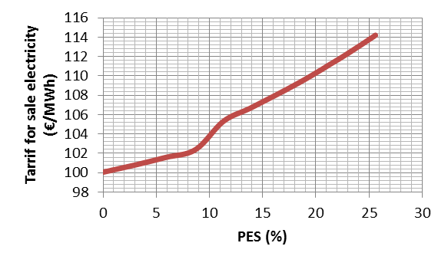

Fig. 2 -Variation of the electric tariff due to PES of the installation.

From the sensitivity analysis performed it can be concluded the following findings:

• The variation in the tariff for sale of electrical energy to the grid varies substantially in a linear manner with PES values, compatible with the notion of "high efficiency cogeneration" and assumes a very sharp fall when the values of PES approach 10% or are lower (see figure 2);

• The variation of indicators (IRR, NPV and payback) of a cogeneration project is mainly influenced by the selling price of electricity. Indeed it is verified that variations of about 10% on the selling price of electricity induce variations in the value of IRR ranging from (-) 77% and (+) 68% from baseline (see table 5);

• The variation of indicators (IRR, NPV and payback) of a cogeneration project is secondly influenced by the cost of fuel. Indeed it is verified that variations of plus or minus 10% of the cost price of fuel induce variations in IRR value ranging between and (-) 73% (+) 65% from baseline (see table 5);

• The variation of indicators (IRR, NPV and payback) of a cogeneration project is, within certain limits, much less influenced by the change in the value of the investment. Indeed it is verified that variations of plus or minus 10% of the value of the investment induce variations in TIR value ranging between (-)10% and (+) 10% of the initial value (see table 5).

Thus it can be concluded that, as a minimum, to enable a profitable operation of a cogeneration facility, the following basic precautions should be taken:

1. Sizing the cogeneration plant always maximizing thermal usages in such a way that the obtained values for PES exceed 10%;

2. Adjusting the operating system of the cogeneration facility to the operating profile of the consumer installation to ensure that in any situation, in monthly actual operation, values of PES less than 10% are never obtained. In this way it promotes the value of the tariff for sale of electricity to the grid;

3. Choose, in the design phase, a generator whose electrical efficiency is as high as possible in order to reduce fuel consumption and thus favoring the second largest factor of production (cost of fuel);

4. Ensure a minimum number of annual operating hours to allow the amortization of the investment in a reasonable period of years.

As already mentioned, the latest legislative changes defined by the Portuguese Government makes the profitability of cogeneration highly dependent on the price of electricity and fuel costs systems. The tariff resulting from the application of Ordinance No. 140/2012 of 14 May, [9] is about 70% of the tariff in the previous legal framework.

Thus, the "business" of cogeneration should be managed by experts and should be viewed in terms of investment as more equipment associated with the production unit whose goal will be to increase the global competitiveness of the productive unit.

The figures for the profitability of the past should be reassessed and assumed values more compatible with current reality.

However, in most European countries, namely Germany, the trend is exactly the opposite, which recently led to an increase of electricity tariffs associated from cogeneration facilities. So, currently, Portugal is going against regulations of several countries of the European Union (EU) with regard to cogeneration.

1. CONCLUSIONS

The cogeneration technology, to date recognized as one of the most efficient ways of producing electricity and thermal energy, has seen its future in jeopardy because of the recent austerity policies which have decreased the remuneration regarding the electricity produced.

The objective of this work was the approach to the new legal framework applicable to the cogeneration activity in Portugal and the execution of feasibility studies according to the new legislative rules that resulted from the publication of the new applicable remuneration regime. In that way an energy audit based on the survey to consumption to the company (annual historic) and based on measurements was performed on an existing cogeneration plant, comparing the results obtained by applying the new legal framework with the results obtained by previous legislation. A sensitive economic analysis was carried where PES, NPV and IRR were analysed, originated by a variation of 10 percentage points of production factors (electricity price, fuel cost) and investment relative to the baseline scenario. The main conclusions are:

The variation of indicators IRR, NPV and payback of a cogeneration project is mainly influenced by the selling price of electricity and by the cost of fuel. However they are much less influenced by the change in the value of the investment.

The avoided CO2 emissions per MWh of electricity produced in the cogeneration process when compared with separate heat and electricity production was also calculated.

So, cogeneration plants in different countries with different regulations must take into account an economical sensibility study.

REFERENCES

[1] C. Afonso. Termodinâmica para Engenharia. FEUP editions. ISNB: 978-972-752-143-2

[2] Commission of the European Communities, 1997. A review of cogeneration equipment and selected installations in Europe, Directorate-General XVII for Energy, OPET.

[3] COGEN, 2011. Micro generation. Porto.

[4] COGEN, 2013, Cogeneration: http://www.cogenportugal.com/ficheirosupload/brochura%20cogeração.pdf

[5] Decree-Law n. º 23/2010, of 25 March, the Official Gazette, Series I.

[6] Directive 2004/8/EC of 11 February, the European Parliament and of Commerce.

[7] Covenant of Mayors, 2013 Technical Annex to the instructions of the model PAES: Emission Factors.

[8] Decree-Law Nº. 538/99 of 13 December

[9] Administrative Rule no. 140/20012 of 14 May, the Official Gazette, Series I-A.