PAPER REF: (to be assigned by the editors)

The Influence of the Location of a Thermoelectric Cooler System on Refrigeration Cabins upon Inside Air Temperatures and Velocities

Clito Afonso
Department of Mechanical Engineering (DEMec), University of Porto, Portugal
Email: clito@fe.up.pt

ABSTRACT
The theory of thermoelectric cooling systems have already been studied for long time ago. The aim of this work is to investigate their use in household refrigerators that usually are based on vapor compression cycles. Being a small piece of equipment and for the typical thermal loads of refrigerators, it allows more useful space and can be placed anywhere inside. In this work, several simulations were carried out using the CFD software Fluent in order to investigate the better location of the cold plate upon the inside air temperatures and velocity profiles, either with natural convection (fan off) either with forced convection (fan on). After comparing the results obtained in several possible locations of the TEC in refrigeration cabins, it was found that the best place is at the center of the top surface with forced convection.
Keywords: Thermoelectricity, simulations, temperature and velocity profiles, Fluent.
INTRODUCTION
The thermoelectric phenomena is known since the late nineteenth century (Thomson, 1851, Magnus, G., 1851, Seebeck, 1895). However its application for cooling only appeared in the 50s, when rapid advances have been made in materials for Peltier cooling, especially through the introduction of semiconductor thermo elements. (Rowe, 1995, Dresselhaus, 2007, Kanatzidis, 2010).
A thermoelectric cooler (TEC) is a refrigeration system based on the Peltier effect. This system uses directly electrical energy for cold production. A scheme of this system is shown in Fig. 1. A thermoelectric module can contain one to several hundreds of pairs (n-type and p-type) and can be connected electrically in series and thermally in parallel.
This system has the advantage of having no moving parts and no working fluid (just electrons) and therefore are very reliable: they can run 105 hours of operation at 100 °C, and even more for lower temperatures (Goldsmid, 1964, 1986). So, these systems are ideal for locations where there are high vibrations and high g's which causes the impracticability of other common systems. Also they allows for a variable temperature control just varying the supply electrical current without reducing life span, and not just on-off as usually used in conventional refrigerators based on vapor compression cycles,. So they enables an optimized temperature control, making it suitable to use in systems with rigorous requirements for temperature control.
The cold junction is connected to a metal plate or other type of heat transfer surface, such as a heat exchanger or cooling substance. On the other hand the hot junction is attached to a surface that allows heat removal to the environment. The electrical current flowing in the circuit is provided by an external source of direct current (DC) such as a battery.
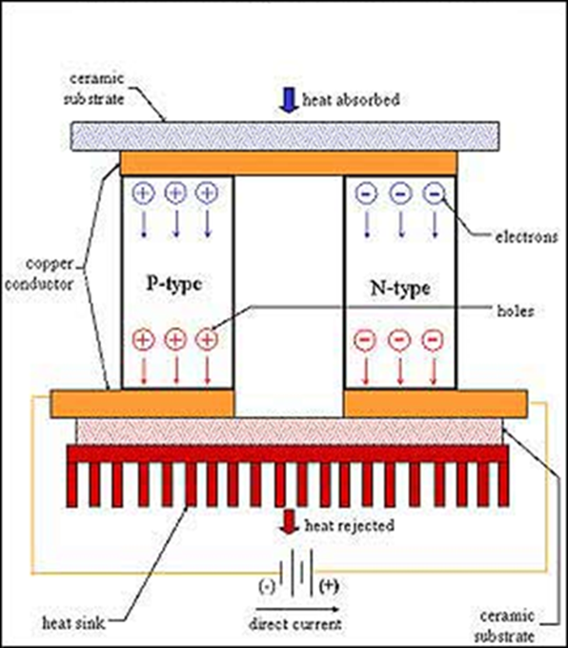
Fig. 1 – Example of a scheme of a thermoelectric module (Elen Enclosures, 1999).
However the advantages outweigh the drawbacks mentioned above. The electrical energy can be harnessed directly from a photovoltaic solar collector, thus eliminating transformation losses for alternating current and thus increasing the performance of the unit (Xi, 2007). This turns them "environmentally friendly", therefore presenting a great advantage over almost all other cooling systems with regard to preserve the environment and reduce harmful gas emissions because there are no working fluids.
Its easy miniaturization and the fact that it can be used in any position due to the absence of moving parts and consequently lack of noise, and using just the electrical power, allows its implementation in small scale applications (Riffat, 2003, Gillot, 2009).
In this work simulations have been done, with the CFD software Fluent (Fluent Inc. 2006), regarding several possible locations of the cold plate of a commercial available TEC in a household refrigeration cabins (replacing the common vapor refrigeration cycle). The main findings was to conclude about the best place to be located taking in account the obtained inside air temperatures and velocities profiles. The simulation was carried out in two situations: the TEC, in several locations in the refrigeration cabin, running only with natural convection (fan off) and with forced convection (fan on).
REFERENCES
Elen Enclosures. (s.d.). 2009. http://www.sarel.co.za/thermoaircon.htm
Rowe, D. (Ed.). (1995). CRC Handbook of Thermoelectrics. London: CRC Press LLC.Siegel AL. Vaginal mesh extrusion associated with use of Mentor transobturator sling. Urology, 2005, 66, p. 995-999.
Seebeck, T. (1895). Magnetische Polarisation der Mettal und Erze Durch Temperature-Differenze. In Ostwald’s Klassiker der Exacten Wissenshaftenj Nr 70. Seebeck Biography 1. Seebeck Biography 2.

