SiFEUP

Author
Lígia M. Ribeiro and Gabriel David
FEUP – Faculdade de Engenharia da Universidade do Porto
lmr@fe.up.pt, gtd@fe.up.pt
The information system of the Faculdade de Engenharia da Universidade do Porto is an integrated administrative IS, covering aspects ranging from the school infrastructures and the academic records, to the course plans, scientific productivity or the external assessment processes. It has been built in-house, since 1996, and it has enabled the progressive modernization of many processes and services providing more accurate decision support.
This report presents the main aspects of the system organized according to the rules for submission to the EUNIS Elite Award.

Goals of the project
The main goal for developing an information system at the Engineering Faculty of Porto University (FEUP) was to enable faster access and dissemination of scholar, scientific, technical and other info-resources, stimulating a stronger collaboration among members of our academic community. The second, but equally important goal, was the possibility to increase the connection and the interaction with other higher education institutions and with industries, especially in the northern region of Portugal.
Some of the most important operational objectives of SiFEUP were:
(1) To store and recover institutional legal data (e.g. financial and employee data);
(2) To increase internal communication effectiveness ⎯ one-to-many (diffusion), many-to-one (recovery), one-to-one (transfer);
(3) To offer to the institutional managers, at different levels, a decision support system;
(4) To continually increase educational quality, giving to the students information about the school, course plans, bibliographic and computational resources, research and social activities, and support services;
(5) To create on-line educational materials, namely to gain recognition as a centre of excellence on new learning techniques and to promote open access to education and provision for distant learning;
(6) To support R&D activities, in particular to help resource discovery and diffusion of research results;
(7) To provide the needed information about the current FEUP activities to the educational and industrial partners, as well as to the general public, establishing an Internet presence in accordance with the institutional mission.
After identifying the objectives, other aspects were accounted for in the system development, including:
- The system is quite large, the information is dynamic and presents different validation periods;
- The system growth is expected to be fast;
- The info-structure accommodates a wide variety of information types, like text, tables, graphics, images, audio and video data;
- Besides Portuguese, the info-resources must also be available in English;
- The system must be flexible and modular. New components must be easily incorporated, such as new types of info-resources, new information providers, or new facilities needed by the end-users;
- The diversity of information providers is large, implying a disciplined intervention;
- Sensible information, like student marks and financial data, must be secure.
It is to these requirements that the SiFEUP aimed to answer.

The environment: administrative, technical and financial constraints
Descending from the Polytechnic Academy created in 1837, FEUP is nowadays a prestigious public institution concerning the national teaching and research of Engineering.
The University of Porto is, at present, the largest university of Portugal, with approximately 22,000 students, 1,800 teaching staff (760 with a PhD) and 1,000 administrative, technical and auxiliary staff. FEUP is itself the biggest Faculty of the University of Porto, with near 5,000 students and 435 teaching staff, 283 with a PhD. FEUP possesses scientific, educational, administrative and financial autonomy and presents a departmental structure, composed of six areas, and several central services to support its activities. This organisation is depicted on Figure 1.
Figure 1. FEUP Functional Organisation.
Presently FEUP offers eight undergraduate courses, 23 MSc and 8 scientific areas for PhD degrees.
Besides teaching, the Faculty carries on research activities and renders services through 9 research centres and 12 interface institutes. These R&D infrastructures account for many national and international projects being simultaneously an excellent backup for MSc and PhD work (near 400 and 300 respectively, at present). These organs have important connections to industries, particularly in the northern Portugal, optimising the scientific, technical, human and material potential of the Faculty towards the development of applied (and also fundamental) research.
Everyone at FEUP can share network resources and gain full access to the Internet. A 2 Mb/sec channel connects the local FEUPnet to the national communication network, RCTS. The local area network, FEUPnet, is an ATM OC12/OC3 network managed by the Computer Centre (CICA). At present there are 6000 active access points and almost 3500 nodes. These nodes comprise central clusters of UNIX/Linux and NT servers, plus several departmental NT and Linux servers, and 30 general computer labs. The ratio student/computer is 5.
Besides being accessible through the Internet, users may access the FEUPnet using traditional analogue telephone lines and ISDN. Near 1000 FEUP students use these facilities to do remote work and access the information resources available, namely those offered by the IS and the Library. Although the Library focus is on the internal resources ⎯ more or less fifty thousand books, eight hundred periodical titles, CD-ROMs, videocassettes, iconography material, maps, etc. ⎯ the registration of external, and mainly electronic resources, is also being done. A significant number of databases in Engineering is available on-line through the Library services.
Portuguese universities have traditionally been conducted by professors and not by professional managers. This includes deans and department presidents but also the directors of some services, like computer centres and libraries. The typical voluntarism of professors induced the administrative system to react through a long-standing policy of excessively bureaucratic rules. The result is a system where processes are complex and slow, staff has an old fashioned perspective of their job and managers have little space to innovate.
Recently, a strong effort is being put on changing this state of affairs at the Engineering Faculty of the Porto University, profiting from a new legal framework that gives more autonomy to the university. One of the directions pursued is the reinforcement of central services. Professional managers have been appointed to some of them, more staff has been hired, and investment in new technology support has been made.
In this context, the Computer Centre assumed the responsibility of the SiFEUP project housing its core team, which congregates the following competencies: information manager, system manager, database administrator, Web programmer, database programmer, designer and data entry operator. These competences are nowadays distributed among ten technicians, though most of the development has been achieved with a smaller team of four professionals and student projects.

The planned scenario of the project and its present state
In the past, a multiplicity of autonomous and disconnected subsystems has been developed within our institution. These subsystems included, among others, applications to control human resources, student records, accounting, R&D projects and publications. These subsystems suffered from important voids preventing the existence of a coherent environment and the automation of a significant number of functions.
The initiative of creating an information system within FEUP was taken by the faculty direction board in 1996. Its strong commitment with the project was essential to make it possible. In effect, the different departments and R&D units within FEUP have large freedom in managing their resources and a high level influence is necessary to push towards the development of an integrated campus wide information system.
To accomplish this task, the direction board formed a working team whose main motivation was to find a balance between the development of an articulated system, moving towards full integration, and the incentives to the information providers within FEUP to creatively produce and disseminate info-resources.
The starting point has been the elaboration of a document with a survey of the status of the information system in FEUP and its intended evolution.
The methodology followed in the IS organization required a detailed knowledge of the corresponding information space, considering the different players and resources involved. Without understanding the role and the responsibility of each player with respect to each piece of contents, it would not be possible to shape the system.
The information space on which SiFEUP was built has three dimensions: (1) information providers; (2) information resources; and (3) information end-users.
Considering the assumed goal of integrating the existing subsystems, a model where the information production was concentrated in a central data-entry service was refused. Although this model could be more effective in a first moment, the distance between the information providers and the data-entry, would lead to delays and mistakes that would reduce the system usefulness. The followed approach favoured the closeness between the maintainers of the info-resources and the corresponding providers. This way, the people involved felt the resources as their own and incorporated them in their daily work routine, reducing the temptation to develop other disarticulated personal tools.
It was then decided that only the elements of the academic community, the units of the FEUP organisation structure, the courses, and the research institutions could maintain info-resources of their own in the system. The decision that only officially recognised units within FEUP could be information providers for the SiFEUP was essential to define the overall high-level organisation of the system.
The correctness and updating of the information associated to each provider is, eventually, the responsibility of its manager.
The end-users belong mainly to the internal academic community, although users at other R&D institutions and industries, particularly on the north of Portugal, are also important consumers. The general national and international publics are the ultimate end-users of the SiFEUP. Concerning end-users, different levels must be recognised, both internal and externally, to which different permissions of access to the system are assigned. The permissions depend on the user profile or on the information resource itself. In this last case a password for the resource is required. In the first case, the access may be established by the user qualification, a personal password being needed, or by the origin of the access, without any password.
The information resources (info-resources) accommodate a wide variety of information types and must integrate multiple sources and repositories. The following table presents a summary of the resources that were initially planned with the implementation degree attained in each case. As can be seen, most of the plan has been accomplished with about 30 of the main modules already available. The remaining modules are under development.

Additional services

 | Resource | Description
✓ | FEUP | FEUP presentation, history, organisation, external links
✓ | News | General and specific notices
✓ | Legislation | Laws, regulations, statutes, minutes
 | Programme
✓ | Plans | Programme descriptions
✓ | Course record | Official information of courses
✓ | Course Web-site | Course support resources
✓ | Teaching service | Allocation of teaching service
✓ | Timetables | Timetables for professors, labs, and classes
✓ | Lab classes | Enrolment in classes
 | Accreditation | Accreditation and external evaluation reports
✓ | Pedagogical assessment | Results of the pedagogical inquiries
 | Continuous education | Continuous education programmes
 | Students
✓ | Official page | Personal data
✓ | Student record | Record of grades
✓ | Personal page | Personal Web page
✓ | Certificates | On-line certificate requests
✓ | Statistics | Statistics of academic results
✓ | Print quotas | Running account of the printing credit
✓ | Academic fees | ATM payment and status
 | Alumni | Professional record, contact, personal page
 | Employment | Help on matching students and employers
 | Staff
✓ | Official page | Personnal data
✓ | Personal page | Personal Web page
 | Staff records | Contracts, qualifications, positions
 | I&D
✓ | Projects | Description, budget, participants, results
✓ | Scientific papers | Bibliography, abstracts
 | Facilities
✓ | Building drawings | Layout of all the buildings and floors
✓ | Rooms | Descriptions of room characteristics
✓ | Assets | Official records
✓ | Computational resources. | Hardware and software available, maintenance
✓ | Resource reservation | Booking of rooms, equipment
 | Other
◉ | Library | OPAC
◉ | Accounting | Economic and financial information
 | Budget | Project budget information
✓ | Trouble Tickets | Management of user support
✓ | Dynamic mail | Dynamic distribution lists
✓ | Foruns | Debate areas
 | Search | General search tool
✓ Available module.
 Module under development.
◉ Autonomous subsystem.
Table 2. Plan execution.
The architecture of the information system has thus two vectors: the consolidation of the data by a relational database and the information access by Web browsers.
The Web technology, mainly because of its simplicity, availability and versatility, was chosen to join up the different components of the SiFEUP. The Web is the ultimate interactive end-user interface with the information system.

Internet
The Web, however, is oriented towards informal browsing in related documents. It is not an efficient mean to discover resources of interest. Actually, it does not yet offer to the programmer tools for the systematic search of well-defined characteristics, but just generic full text indexing engines. Besides, it does not possess an automatic consistency maintenance mechanism. On the contrary, it favours a certain amount of redundancy. Database systems have already successfully addressed these problems and the SiFEUP makes use of their potential. This option is supported by the existence of software that transforms the result of a database query into an HTML page, dynamically generated but sent to the Web client as a normal static page.
Though the information system involves an important part of structured data (90%), unstructured HTML pages are also present. This dual approach was taken to allow FEUP information providers to build easily their own info-resources and facilities without bureaucratic constraints, according to their preferences and specific goals. These pages are organised around a framework supported by a central working team.
For instance, the basic information relative to the FEUP courses is structured data easily searchable using pre-defined criteria. The database itself contains the URL of the HTML pages designed and maintained by each professor that complements the official information with specific learning resources.
The information system evolved along the general directions described above, but with a gradual implementation subject to periodic evaluation to allow for trajectory corrections.
The first phase has been devoted to record the basic facts about the school’s activity, and lasted from 1996 to 1998. In a second phase (1998-2000) the previous modules were refined according to the experience already accumulated and to the suggestions received from the users and it was added a new layer of services corresponding to the extraction of relevant derived information specifically designed to support the several levels of school management.
The information space resources identified largely inspire the organisation of the Web site. The access to them is usually present in a menu on the left side of the pages. Modules connected in various ways compose most resources. The full system is reachable at the URL http://fe.up.pt. Descriptions of specific parts are also available in [1,2,3,4 – see annex].
For the sake of clarity, a few example modules are presented below in the form of a tour guide for the following situation: On September 2000, the Faculty moved to a new location, in the city periphery. This new location almost triplicates the previous area. How could the SiFEUP help a professor in the move to the new premises?
On the home page see whether there are relevant news. The news module contains short notices posted by the different units of the faculty, which are automatically displayed and discarded according to a predefined schedule, and can be selectively viewed according the user profile. The user will be prompted to a single sign-on to authenticate himself if the resource requires it.

First step
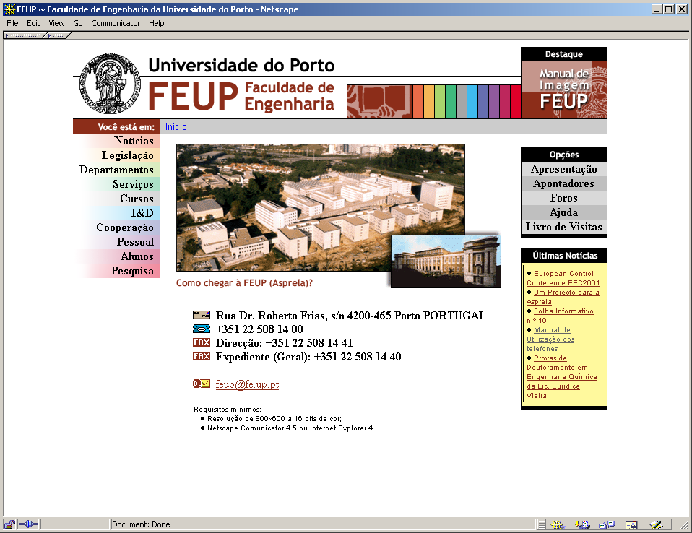
Selecting the option Pessoal (Staff) on the left menu find your official SiFEUP page. A query form allows the specification of several search criteria. Such a page exists for every member of the staff (as well as for every student) and contains all the relevant information concerning your activity in the institution: contacts, position, teaching service in the last years, timetable, publications, projects. If the user maintains a personal Web page he may specify its URL in a configuration form attached to the official page, where the link becomes automatically included.

Second step
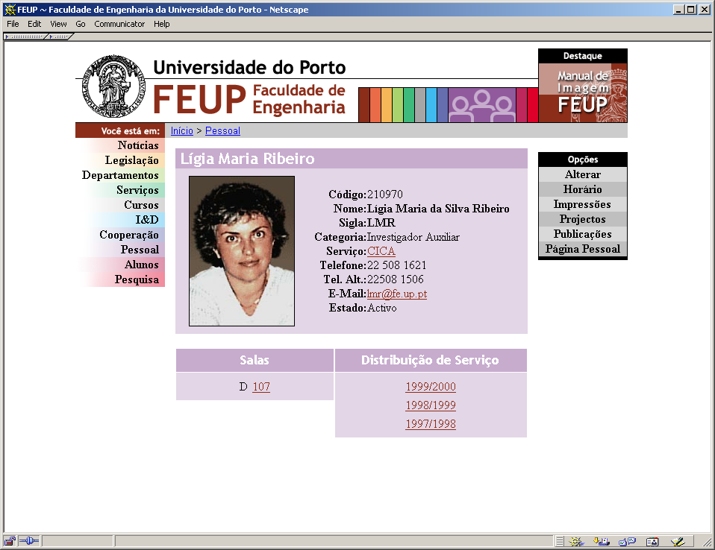
Following the link for the user’s office a drawing of the floor and building will be displayed.
Locate the office in the map. See the room description, telephone, number of network access points and configuration information including IP address, computer name (can be changed by the user in this page), and DNS and WINS addresses. This page contains an option for the room timetable that, in a classroom shows its lecture hours. In an office it may be used for the student answering hours.

Third step
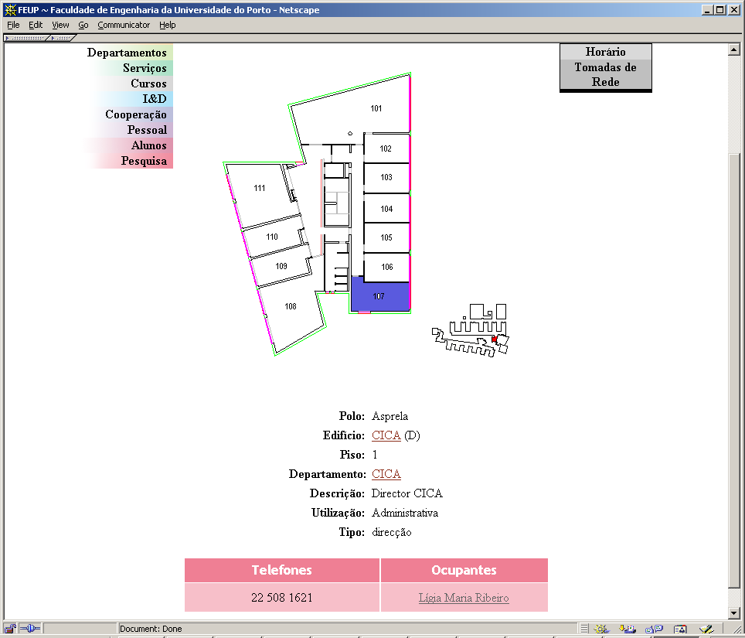
Back in the official personal page see your timetable and follow the links to the lectures. Find where are the different rooms, the classes, and the official course pages, containing the objectives, syllabus, assessment, bibliography, list of registered students, their photos, pedagogical inquiries, and course performance statistics. From the list of students select the e-mail option and warn your students about the beginning of the lectures.

Fourth step
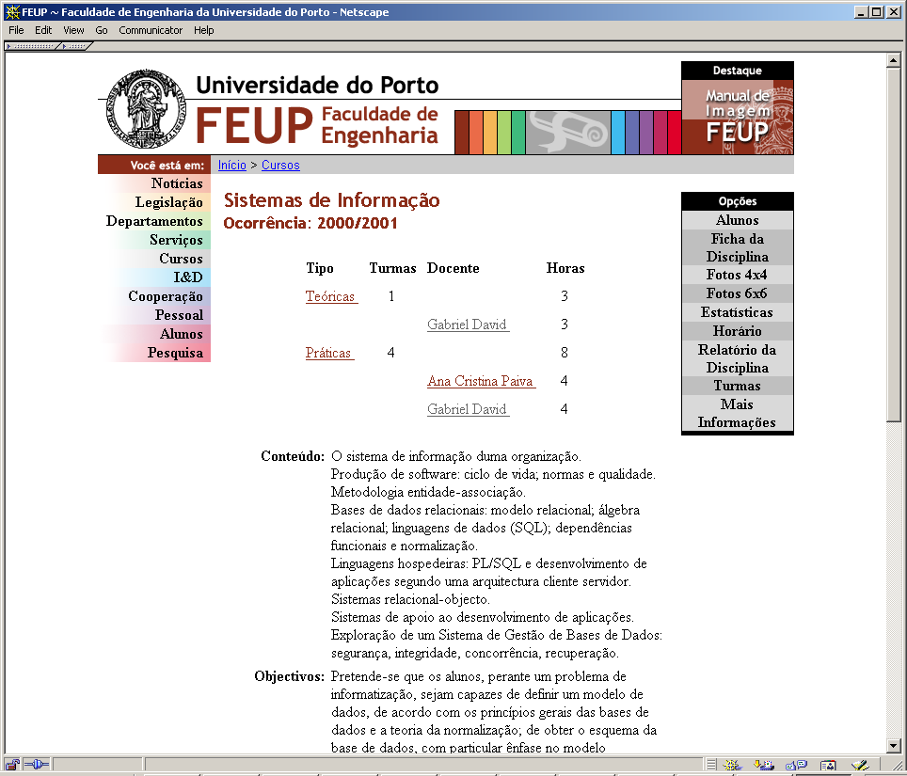
Find through the option Serviços (Services) the computer center and the trouble tickets (TT) module. Start a new TT asking for the creation of a set of database accounts for the students attending your lectures.

Fifth step
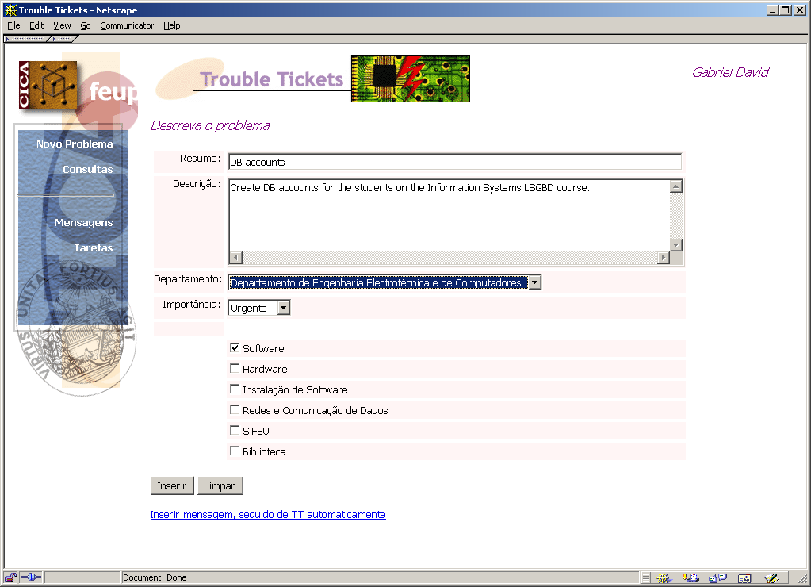
Follow at any moment the evolution of your request using the TT module.

Analysis of the results and impact on the institution
The measure of the adequacy of the SiFEUP becomes fully significant only in the framework of an evaluation of the performance of the Faculty itself. As the development of the SiFEUP is done in-house by a team who knows how it works, a first degree of correction is guaranteed. Several meetings with the directors of departments, services and courses have been promoted. There is an e-mail address where people send comments, suggestions and requests. A guest book page in the system where everybody can leave a public message is also available. From these feedbacks, adjustments are done in the system in order to extract the information in the way and at the time it is more useful to its consumers.
The information system has been running for the last four years. Most of the planned components are available and significant improvement is noticeable.
The SiFEUP is now widely used by all members of the academic community, from students to teachers and staff, and in relation to all aspects of the faculty activities, meaning teaching and learning, research and development, administration and management. To enforce such use, a number of presentations took place both for teachers and for students, mainly those in the first year, as well as training sessions for the staff.

User education
The following list highlights some of the more visible improvements on access to information obtained with the system:

Before SiFEUP | After SiFEUP

Room availability
Disperse and hard to consult | On-line for all the school rooms

Internal phone list
Paper list seldom updated | Always updated and including second number

Student records
Visit to the academic service to consult the records | Student record on-line, with password

Certificates
Two visits to the academic services | On-line request and process evolution monitoring

Course and teacher timetables
Separated by programme, consult in the staff room | Single on-line timetable integrating all the programmes

Enrolment in lab classes
Lengthy process done by hand | Enrolment via Web preference form with automatic allocation

Messages to the students
Contact between classes very difficult | Immediate, using the dynamic mail list facility

Regulations
Paper copy from the administrative service | Relevant regulations on-line (restrict access)

Pedagogical assessment
Lengthy semi-manual processing, restrict dissemination | Automatic processing, aggregate results on-line

Accreditation/external assessment
Manual process organization | Statistical tables extracted from SiFEUP, on-line publication

Project information
Sometimes available in annual reports | On-line searchable list

Scientific bibliography
Sometimes available in annual reports | On-line searchable list with selective bibliography print
Table 3. Impact.
Being a fully integrated modular system based on relational database technology and universally accessible through the college intranet ensures together the quality of the information, in terms of consistency and versatility of its use, and its wide availability, which brings closer the central services and all the members of the academic community. A change in some data, for instance a new telephone number or a new timetable, immediately shows up in all the related queries. Efficiency grows because a number of telephone calls, personal enquiries, and wrong assumptions are avoided.

De-centralization

Other examples of increase in efficiency and productivity of some processes:

Efficiency & productivity
- the information on teaching service guides the printing of exact numbers of the pedagogical enquiry form, with the identification fields already filled in, thus reducing the processing time and the number of optical reading errors;
- students may use, in a self-service basis, any of the printers equipping the 30 computer labs supported by the computer centre; in the beginning of the semester they are credited with a number of pages which may depend on the programme and year; each print job is recorded and a summary is reachable from the official student page, where the balance can be controlled and new payments are recorded;
- several reports, like accreditation processes, departmental scientific activity reports, and personal activity reports, require information on scientific publications, research projects and teaching service; the availability of such information in the SiFEUP releases the burden of repetitively answering the same questions and improves the document preparation efficiency.
The synergies among the existing resources make easy to install new modules, like happened with the module to produce the fee payment forms via ATM and control the corresponding execution, or the module for the car parking cards issue and control.

Rapid development
In general, the utilization of the several modules represents an improvement in the way administrative processes are performed. The effectiveness of the modules in changing the response capacity of the services goes along with decreased individual dependency, more uniform external image, and higher quality standards. The concern of generality under which the modules were designed makes an easy task to deploy them to other services in the college, thus spreading the good administrative practices they induce. Many modules include flexible access control, with the ability to dynamically define groups of responsibility.
The impact of the SiFEUP may be evaluated from different points of view. From the users perspective the communication facilities, the up-to-date information, the possibility to post and follow the evolution of requests, as well as the possibility of quantifying the quality of the services offered, are the most relevant improvements.
The system helped a lot the modernization effort carried out by the FEUP direction board. The school management has now more accurate sensors of the actual academic and research activities, which support decision-making better suited to the school reality. Also, the task of convincing the professors to answer inquiries and produce information has been facilitated because the transparency of the IS exposes to everybody the misses and the possibility of on-line data entry simplifies the work.
The development of a complex system brings always difficulties. The main current problems are:
- The lack of technical staff. This delays the release of new components. In fact, most of the development effort comes from students working as temporary collaborators or within curricular projects;
- The need to increase co-operation between the FEUP units. The policy of assigning the responsibility of keeping the data updated to the corresponding unit requires a co-operation that is not always easy to obtain. As happens with every organisational change, there are habits to modify and different models and perspectives about the institution to acquire.

Designing the intranet around a database requires an extra effort of systematisation and modelling of a complex organisation like a faculty is. But it pays off in terms of consistency, reliability and flexibility of the information system, which becomes an infrastructure able to support new developments.

Cost-effectiveness
Indeed, the SiFEUP has been designed to be a service as well as an infrastructure. This way, it is relatively easy to develop new modules, perhaps of restricted interest, which profit from the information already included in the system and leverage its application. Several course assignments for students on databases and information systems lie in this case.

Further developments
The current plans for the future include:
- revising the earlier modules to improve its usability;
- add access to the budget execution data;
- improve information on personal records;
- articulate a better module for alumni;
- generalize on-line registration;
- add new statistic indicators and perform knowledge extraction to identify potential performance problems.

Application to other institutions
The development of SiFEUP has been shaped by the context of the Engineering Faculty. However, the similarities among higher education schools in Portugal should make feasible its installation in other schools. Such an experience has not been carried out yet, despite the significant number of demands for that, mainly because the decision of supporting external institutions has strong implications on the size and organization of the maintenance service.

Conclusion
This report presents the experience of creating a modular and flexible system to organise, access, communicate and search large amounts of information, related to the Engineering Faculty educational, research and administrative activities.
The motivation behind the project and the approach selected are both described. It is shown that a dual-based approach, on the Web and database technologies, is adequate to benefit from the capabilities of storing, structuring, and searching large amounts of data, with adequate exploring tools and levels of security, and to access these same data with simple, versatile and widely used tools.
The experience here summarised may be useful for other sites that wish to manage and share large amounts of on-line information, in an integrated and extensible fashion.

References
[1] Ribeiro, Lígia M.; David, Gabriel; Azevedo, Ana M.; Marques dos Santos, José C. “Developing an Information System at the Engineering Faculty of Porto University”. In Yves Epelboin, EUNIS 1997, Grenoble.
[2] Ribeiro, Lígia M.; David, Gabriel. “Using an Intranet for effective Communication”. Poster in EUNIS 1998, 1998.
[3] David, Gabriel; Ribeiro, Lígia M.. “Getting Management Support from an University Information System”. Proceedings of the European Cooperation in Higher Education Information Systems, EUNIS 1999, Espoo, Finland, 7 - 9 June, 1999.
[4] Ribeiro, Lígia M. ; David, Gabriel; Wilson, Jorge; Ribeiro, Jorge. “Changing Procedures in the College Central Services”. Proceedings of the European Cooperation in Higher Education Information Systems, EUNIS 2000, Poznan, Poland, 2000.

