**Análise de Sistemas Frigoríficos Destinados a Bebidas de Pressão**

**Clito Afonso1*, José Garcia1 and Joaquim Gabriel 1,2**

1Faculdade de Engenharia da Universidade do Porto. R. Dr. Roberto Frias, 4200-465 Porto, Portugal

2IDMEC, Polo FEUP. R. Dr. Roberto Frias, 4200-465 Porto, Portugal

*Corresponding author: [clito@fe.up.pt](mailto:clito@fe.up.pt)

**Keywords:** sistemas frigoríficos, simulação, otimização, experimentação

**Introduction/Background**

Refrigeration systems for draught beverages are usually available in all kinds of catering services, being responsible to cool down different kinds of beverage from the environment temperature down to 3ºC. As they can be found in several thousand places and its operation runs for 24h per day and per year, the knowledge of its performance is relevant for the energy consumption. Thus, a common machine of this kind was fully instrumented with sensors to evaluate its behaviour. Additionally, it was used the EES software for simulations as well as tests were carried out in laboratory environment. Based on both results, strategies to improve their efficiency are discussed as well as the significant decrease in the energy consumption and associated CO2 emissions released by the power plants due to improvements that can be carried out in the working system.

**Experimental/Analytical/Simulation**

A view of one of these system is shown in Fig.1. It was full monitored and tests were carried out in laboratory environment.

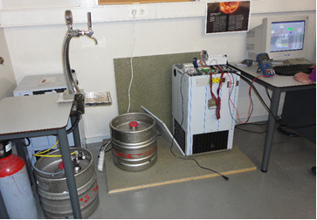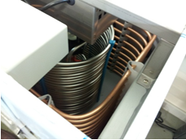

CO2

bottle

Beer

barrel

Column

and tap

Refrigeration

system

Tank

Evaporator

Beverage

coil

Fig.1 – View of the system tested.

A scheme of draught machines like the one tested is shown in Fig.2 and, delivers fresh beverages mixed with pressured CO2 gas.

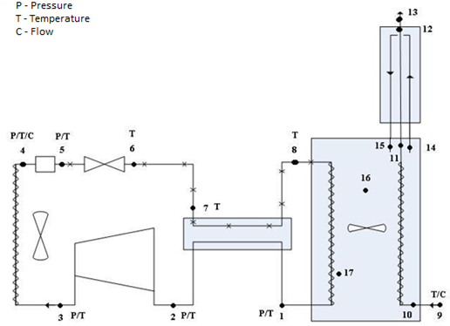

Filter

Capilary

tube

Evaporator coil

Column

and tap

Tank

Condenser

coil

Stirrer

Beverage

coil

Internal heat

exchanger

Compressor

Condenser fan

**Refrigeration subsystem**

**Beer subsystem**

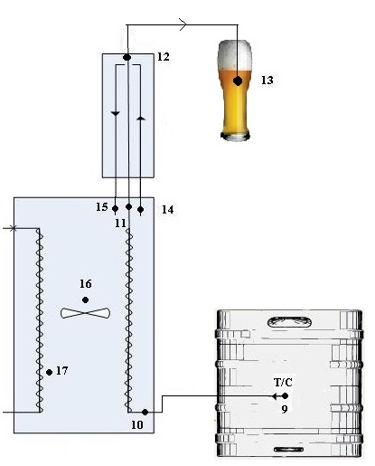

b)

b)

Fig. 2 a) The two sub systems and location of all sensors (p – pressure, T - temperature); b) beverage subsystem (right of the vertical dashed line) and the location of the temperature sensors.

These machines can be divided in two subsystems, the refrigeration machine itself and the beverage subsystem, which get together in a tank with an iced water (around 0 ºC), sited on the top of the first one. This tank is responsible for the heat exchange between the evaporator coil, made of cooper, and the iced water, and then from this last one to the beverage coil, made of stainless steel, The production of iced water by the refrigeration system is an intermediate process to cool down the beverage at about 3 °C, and is not the desired goal itself. As it will be seen, the formation of ice is the drawback in the whole system, as it is a major energy consumer. However it represents a necessary buffer to help the maintenance of the temperature, even in the event of temporary failure, or lack of power, of the refrigeration system. The refrigeration system is based on a simple vapour compression cycle, [1], with an internal heat exchanger and the working is R-134a.

The system was instrumented with several sensors for temperature, pressure, flow and power consumption measurements to evaluate the behaviour of the system and to develop new approaches towards the overall optimization.

To promote the heat exchange between both coils, and to maintain an almost constant temperature inside the tank, there is a stirring apparatus placed in its centre, figure 2.a that works continuously.

As a pre-set factory value, the compressor stops for periods of 23 minutes, independently of the heat gains through the tank. During this period, the initial mass of ice inside the deposit starts to melt. After this period, the compressor starts to work again in order to restore the initial mass of ice with a variable running time that is a function of the beverage flow rate pattern and of the ambient temperature. The initial thickness of ice in the tank is fixed to 30 mm (factory set), which corresponds to 25 kg of ice. The ice mass is monitored by a probe placed in the evaporator and connected to the control module. The thickness of ice can be adjusted by moving the ice detector away or in the direction of the wall, in order to obtain different ice masses. The ice detector prevents all the water to freeze, turning off the system when it reached a predefined limit for the thickness of the ice over the evaporator coil.

To evaluate if the initial mass of ice needed to cool down the draught beverage is the necessary one (as mentioned, the pre-set value factory default is 25 kg), different simulations were carried out: one with the pre-set value, the second one with an initial mass of 21 kg and a third one with 10 kg. It was used the Engineering Equation Solver, [2] and the equations of heat transfer, [3, 4].

The following data were considered as constant:

• the refrigeration system was already connected the day before the consumption, so the machine is in a steady state;

• the refrigeration system stops when the mass of ice formed reaches the pre-set value;

• the beverage temperature at the outlet of the column is 3 ºC;

• the beverage temperature in the barrel is equal to the average ambient temperature, that varies with the different situations considered (winter, summer);

Several typical situations were simulated: small restaurants during winter and summer time and bars, also in both seasons. In order to evaluate the beer consumption scenarios in both kinds of establishments, a questionnaire was made in several similar establishments. For the simulations, the beer barrel was considered inside laboratory therefore its temperature was equal to the internal air temperature. The results presented in the next section concerns only with the bar in summer time, as it is the worst situation due to the higher ambient temperatures, a large beverage consumption (the conclusions obtained in the remaining situations are about the same).

The influence of the initial temperature of the beverage in the barrel was also analysed in terms of energy consumption and the global COP of the system.

**Results and discussion**

With the measured thermodynamic properties of the working fluid in several points of the refrigeration system, as well as with the measured power consumption of the compressor, shown in Fig.3, it was possible to carry the total thermodynamic analysis of the cycle, as shown in Table 1.



= 35.83ºC

= 9.09 bar

= 31.08ºC

= 7.948 bar

= -6.01ºC

= 1,53 bar

= 62.89ºC

= 9.14 bar

= -6.33ºC

= 1,53 bar

= 36ºC

= 9.14 bar

= -16.6ºC

= 1,535 bar

= 13.88ºC

= 4.714 bar

= 0.5521 kW

Fig. 3 - Diagram of the refrigerating machine as well as the measured thermodynamic properties of the various states and the compressor power.

Table 1 – Results of the thermodynamic analysis of the refrigeration cycle.

|  |  |  |  |  |  |  |  |
| --- | --- | --- | --- | --- | --- | --- | --- |
| [W] | [kgs-1] | is,comp  [%] | cond  [W] | evap  [W] | HE  [%] | filter  [W] | COPR  [-] |
| 552 | 0.01262 | 80.8 | 2469 | 1912 | 1.5 | 3.2 | 3.14 |

The COP of the refrigeration system is:

The efficiency of the internal heat exchanger is:

Some conclusions can be drawn, namely:

* the COPR has an acceptable value for this kind of systems;
* the compressor has an isentropic efficiency within the expected ones;
* heat losses in the filter are very small and may be considered negligible;
* the efficiency of the internal heat exchanger is extremely low. This is explained by the fact that it is virtually non-existent (it composed of two pipes that only contacts here and there with a polyester insolation round them). The system has only to gain from the implementation of a more efficient heat exchanger.

As said, a simulation was carried out in order to verify if it was necessary the pre-set amount of ice in the tank In this case, it was considered an ambient air temperature ranging from 18 ºC at 00:00h to 23 ºC at 15:00h (typical at Porto), and it was assumed a linear variation of temperature between both.

Fig.4 shows estimated beer consumption pattern and the ice mass evolution along the time in the tank, for the three different initial mass of ice considered. Table 2 shows the results of the total energy consumption in these three situations, for one machine operating for 24h, and per year, as well as the COPR and the COPG.

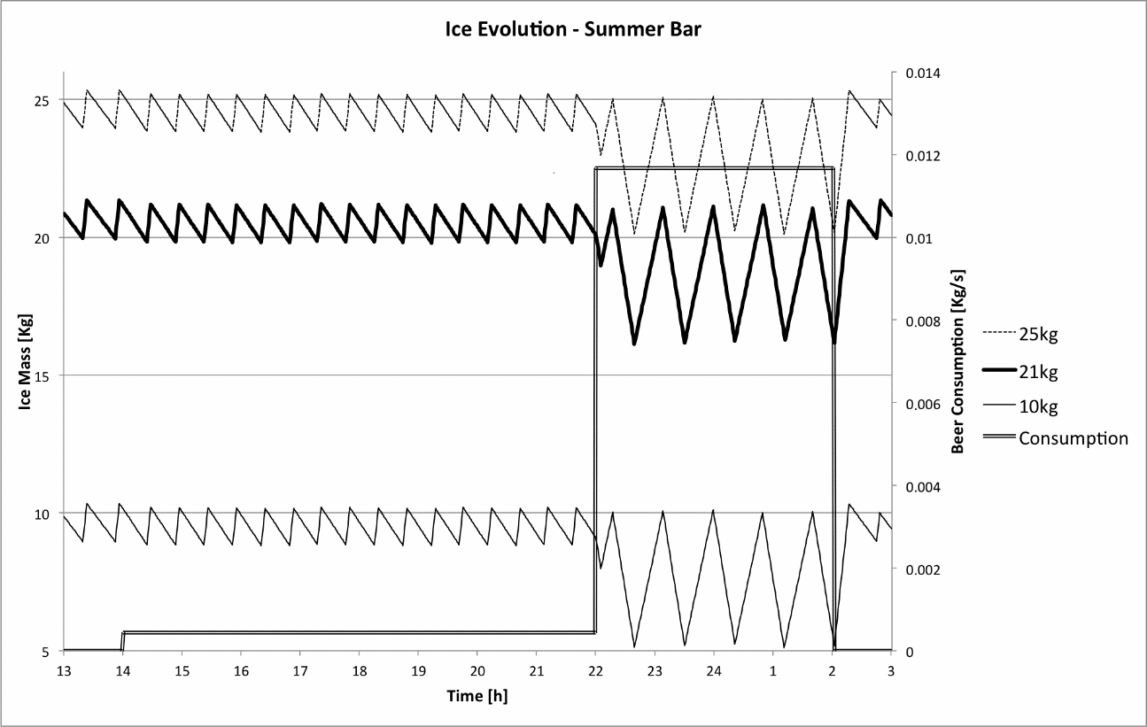

Fig.4 - Beer flow rate and ice mass evolution in the tank along the time for the three mass ranges of ice – bar, summer time.

The COPG of all the refrigeration system is:



Table 2 – Daily and annual energy consumption per system in the bar.

|  |  |  |  |  |  |  |  |
| --- | --- | --- | --- | --- | --- | --- | --- |
|  | COPR  [-] | COPG  [-] | Running Time of Compressor [min/day] | Energy (Compressor and Fan) [Wh] | Stirring Energy and Ice Sensor [Wh] | Daily Energy [Wh] | Annual Energy [kWh] |
| Initial Mass of Ice of 10, 21 and 25 [kg] | 3.14 | 0.891 | 293 | 2980 | 1559 | 4539 | 1657 |

As said before, there is a stirring apparatus placed in its centre of the tank that works continuously.

So, when the establishments are closed, there is a large energy consumption without any profit (no beverage consumption). So, to diminish it, the machine may be switched off during the closing time. As saw, while the initial mass of ice in the tank doesn’t affect the energy consumption of the system when it works permanently (there is always ice in the tank), in the case of switching it off during the closing period, it affects, because when the establishments opens the deposit must already have the initial mass of ice inside. In this situation, it is of an extremely importance to know the time spend and the associated energy consumption to restore the initial mass of ice, for the three analysed situations, 10, 21 and 25 kg of ice, after being switched off , in order to see if it compensates to turn the machine off. Table 2 presents the results obtained.

Table 2 – Necessary time to form the initial mass of ice: all the system starts to run without ice and without beverage consumption.

|  |  |  |
| --- | --- | --- |
| Initial mass of ice needed [kg] | Time [min] | Energy [Wh] |
| 10 | 30 | 338 |
| 21 | 62 | 698 |
| 25 | 73 | 821 |

Table 3 shows the results obtained in the energy savings and the associated reduction of emissions of CO2 (taking into account the electricity generation mix in Portugal that results in a CO2 emission is about 0.47 kg per kWh of electricity produced [AdEPorto, 2008]), per system and per day as well as per year around for all the systems of the company (“Unicer Bebidas” the company that supports this research project, have in Portugal 40k systems like the one tested) if they are shut down during the closing of the establishment (12 hours).

Table 3 – Benefits of switching off one system during the closing period of the establishments (12h) and for all systems of the company (40k).

|  |  |  |  |  |  |  |  |
| --- | --- | --- | --- | --- | --- | --- | --- |
|  |  |  |  |  |  |  |  |
|  |  |  |  |  | Initial mass of ice needed [kg] | | |
|  |  |  |  |  | 10 | 21 | 25 |
|  |  | Energy consumption:  (switched on for 24h) [Wh] | | |  | 4539 |  |
|  |  |  |  |  |
|  |  | Energy consumption:  (switched off for 12h) [Wh] | | | 2628 | 2968 | 3091 |
|  |  |  |  |  |
|  |  | Energy savings per day [Wh] | | | 1911 | 1571 | 1448 |
| Bar | | Annual energy savings:  all systems [GW] | | |  |  |  |
|  |  | 27900 | 22937 | 21141 |
|  |  | Reduction in emissions  of CO2 per day [kg] | | |  |  |  |
|  |  | 0,9 | 0.74 | 0.68 |
|  |  | Annual reduction in emissions  of CO2 for all systems [ton] | | |  |  |  |
|  |  | 13140 | 10804 | 9928 |

**Conclusions**

In this study a refrigeration system designed for cooling draught beverages was analysed for different establishments, and beverage consumption. A cycle analysis of the refrigeration system was done with the measurements carried out. Also simulations with EES were done, as well laboratory tests. It was possible to conclude that they are in agreement, which validates the simulations carried out. While the COP of the refrigeration system is acceptable, about 3.14, the COP of the whole system is very low, respectively of 9.57E-02 and 0.891 for a restaurant and bar in summer time with a typical beverage consumption pattern. This is due to fact that the refrigeration system is used to make ice, instead of cooling down the beverages directly. Several inefficiencies were detected in the system that may be fixed in the future. The first one is the very low value of the efficiency of the internal heat exchanger (1.5%), the larger temperature difference between the recess of the refrigeration system (where the compressor and condenser is located) and the heat released by the stirring motor and the iced water. So an improvement can be achieved by increasing the thermal insulation of the bottom surface and isolating the stirring motor. These will reduce the energy consumption of all the system. During the normal function of the system, the initial mass of ice in the deposit didn’t cause any difference in the energy consumption of the system (10, 21, and 25 kg). However if the system is switched off during the closing time of the establishments, the initial ice mass in the tank does a larger difference in the energy consumption of all the system (GW), as well as a decrease of emissions of CO2 released to the environment by the power plants (tons per year which varies with kind of establishment and consumption pattern. With the two simulated cases, restaurant and bar in summer time and with two different consumption patterns, it was proven that an initial mass of ice of 10 kg would be enough to overcome an extra peak consumption of beverage.

**Acknowledgments**

The authors would like to thank to the support of UNICER Bebidas and University of Porto, through the “Projectos Pluridisciplinares, Concurso 2010” programme,

.**References**

1. C.F.Afonso, Termodinâmica para Engenharia, *FEUP editions*, 2012. ISBN 978-972-752-143-2.
2. EES – Engineering Equation Solver Software, accessed on September 2013, <http://www.mhhe.com/engcs/mech/ees/>
3. F. P. Incropera, Fundamentals of heat and mass transfer, Vol. 6th ed. Danvers: *John Wiley & Sons*, 2007.
4. B. Gebhart, Heat transfer, Vol. 2nd ed, New York*, McGraw Hill*. 1971.
5. J.J. Garcia, Melhoria do Desempenho de Sistemas Frigoríficos Destinados a Bebidas de Pressão, M.Sc thesis, *Feup*, 2014.
6. S.M.S. Murshed, C.A. Nieto de Castro, A.P.C. Ribeiro, M.J.V. Lourenço and U.V. Mardolcar, Heat capacity of nano- and ionano-fluids, *19th European Conference on Thermophysical Properties*, Thessaloniki, Greece, August 28-September 1, 2011.