Searching Dynamic Web Pages With Semi-structured Contents
Filipe Silva, Armando Oliveira, Lígia M. Ribeiro, Gabriel David
Faculdade de Engenharia da Universidade do Porto, Portugal
{fsilva,armando,lmr,gtd}@fe.up.pt

Abstract
At present, information systems (IS) in higher education are usually supported by databases (DB) and accessed through a Web interface. So happens with SiFEUP, the IS of the Engineering Faculty of the University of Porto (FEUP). The typical SiFEUP user sees the system as a collection of Web pages and is not aware of the fact that most of them do not exist in the sense of being an actual HTML file stored in a server but corresponds to HTML code generated on the fly by a designated program that accesses the DB and brings the most up-to-date information to the user desktop. Typical search engines do not index dynamically generated Web pages or just do that for those that are specifically mentioned in a static page and do not follow on the links the dynamic page may contain. In this paper we describe the development of a search facility for SiFEUP, how the limitations put to indexing dynamic Web pages were circumvented, and an evaluation of the results obtained. The solution involves using a locally developed crawler, the Oracle Text full text indexer, plus meta-information automatically drawn from the DB or manually added to improve the relevance factor calculation.
Keywords: University Information Systems, Web Search.
1 Introduction
At present, information systems (IS) in higher education are usually supported by databases (DB) and accessed through a Web interface. So happens with SiFEUP [7,8], the IS of the Engineering Faculty of the University of Porto (FEUP), which started operating on 1996.
Most of the information it contained during the first years was structured data like student records, programme curricula, personnel records, service assignments, class and exam schedules, bibliographic records, etc. All this information could be accessed by navigation in the intranet, complemented with database searches driven by form specified criteria. This kind of search is efficient, especially if the fields used are indexed in the DB, but limited to the pre-programmed forms and separated by category of data. For instance, if one is interested in searching for information on a certain prominent professor about whom papers have been written, two different queries would be needed: one to search the personnel records and find his official Web page, and another to search the titles of the bibliographic records and find the relevant papers.
The typical SiFEUP user sees the system as a collection of Web pages and is not aware of the fact that most of them do not exist in the sense of being an actual HTML file stored in a server but corresponds to HTML code generated on the fly by a designated program that accesses the DB and brings the most up-to-date information to the user desktop. So, it is reasonable for the user to expect [Rappoport, 2000] for a search facility like a Web search engine that, to the query with the professor's name, would answer the list of all the pages containing it, irrespective of the DB field it comes from.
This approach works very well for file based Web sites, as it is flexible, does not constrain the user and does not require a certain familiarity with the site structure. The disadvantages are the amount of extra storage to keep the required indexes on all the words in the pages and the amount of perhaps irrelevant pages it may bring along. For instance, the Web pages of all the courses the professor have lectured would be listed, too. Moving from the form based DB search to the Web search engine means increase on the recall but less precision of the search.
A more difficult problem with this second approach is that it isn't really a solution as it fails in too many cases. Typical search engines do not index dynamically generated Web pages or just do that for those that are specifically mentioned in a static page and do not follow on the links the dynamic page may contain. There are a number of technical difficulties for this, one of them the possibility that activating automatically a form to find its results may have undesired side effects like changing the DB; another, the impossibility to generate all the possible combinations of values a user query might specify.
However, the problem is getting worse in recent years as new modules were added to the system, like one to record the class summaries. The most relevant pieces of information in these records are unstructured documents that the user would like to search freely.
2 Adding semi-structured contents
One of the main goals of SiFEUP is to support the several phases of the pedagogical process. It begins in January with the definition of courses that will be offered next year, according to the study plans. Then the program directors establish the number of different classes for each course and ask the relevant departments to take care of each one. During May, the department directors distribute the teaching service. The professors may then prepare the course outlines for the forthcoming year and plan their classes. At the same time, the class timetables are prepared. In the beginning of September, the students register for the several courses and, if applicable, to specific timetables and classes begin. During the semester, the summaries of the classes are published. Two other communication mechanisms, besides face-to-face or remote classes, can be used: there is an automatic mailing list for each course and also a private forum. By the end of the semester, the students fill in a pedagogical inquire on their assessment of courses and professors. To organize the final evaluation, the exams schedule is prepared and professors are assigned to proctor each exam. The final marks are then published and recorded. They can then be consulted on a per course basis or in the student records, for a personal view. Certificates can be asked for. A number of statistics, at the course and program levels are available. To finish the process, professors complete course reports, and program directors elaborate yearly program reports, which include several of those statistics. All these phases are supported by specific modules in the IS.
The summaries module supports running a course in two different moments: during the planning phase and also along the classes. To plan the course means to specify the intended summary of each theoretic lecture and each practical class for all the weeks of the semester (see Fig. 1). Besides, if there are already relevant documents like presentation files, homework assignments, examples, extra papers, etc., they can be just appended to the respective summary.
The module is an effective collaborative tool as it is accessible, through the Web, to the teachers involved in the course, who can contribute to it or just share it to prepare the classes. It is also possible that different teachers keep their own plans, if they prefer to run their specific classes in different ways. If the course has already been taught in previous years, it is possible to import the plan or the actual summaries of one of them to be used as a starting point for the new plan.
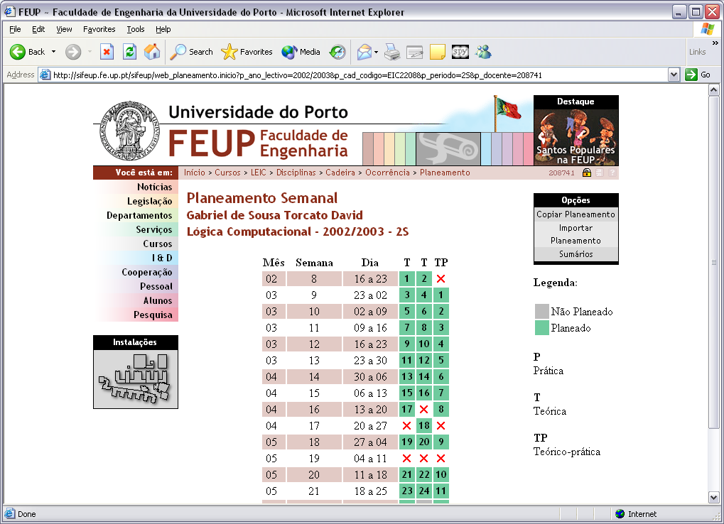

Figure 1: Preparing a new course plan.

The second function of the module is to record the actual summaries for the classes. There is an initialization step which must be performed only after the weekly class timetables are prepared, with a different module (see Fig. 2). Using this information and the pedagogical calendar, which defines the semester start/end dates, the vacations and holidays, a template is built with all the classes each professor of the course is supposed to teach.
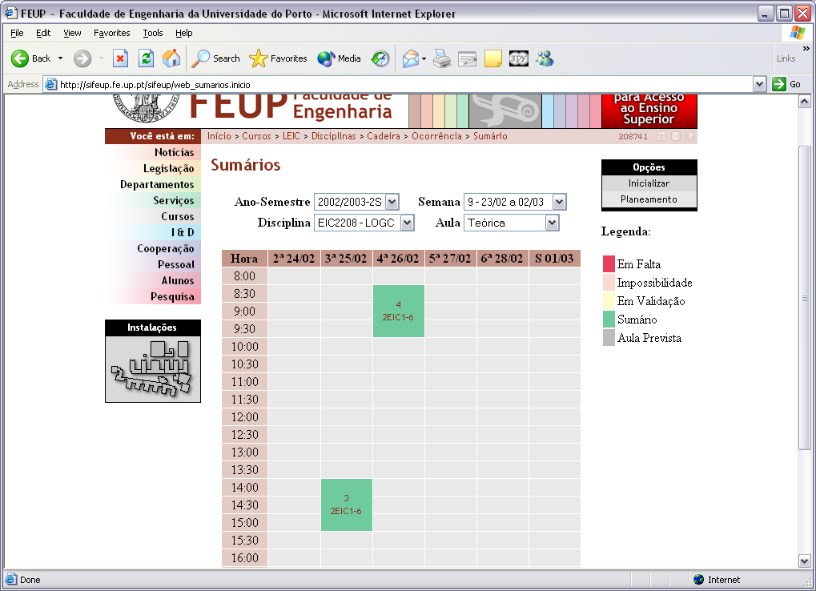

Figure 2: Class summaries template.

Publishing the summaries is mandatory. So, after each class, the teacher must fill in the actual summary (see Fig. 3). It may be just typed in or, if there is a plan, copied from the planned summary with the same number and, possibly, adapted. If the plan includes attached documents, these are also copied and, if convenient, changed or complemented. These documents are actually stored in the database, but they could be left in the file system and record just their location in the DB. In courses with more students, it is common to repeat the same class for different groups. It is possible to associate the several occurrences, in the respective days, with the same summary. If a change of date happens, there is a second date to record it.
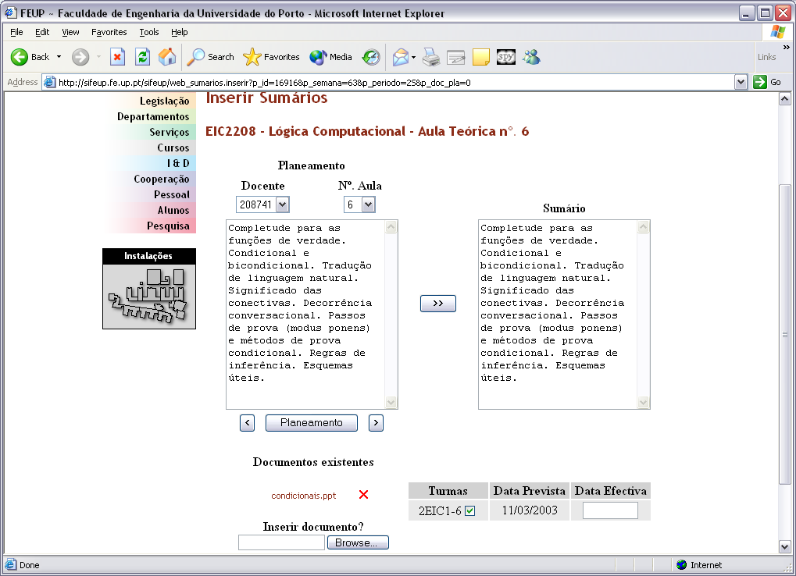

Figure 3: Typing in a specific summary.
The students get a centralized and easily accessible way to know the relevant info about the class (see Fig. 4) and the professors avoid the burden of maintaining a specific site for their course. It is possible to export the summaries of a course in XML to update palm top computers or other personal files.
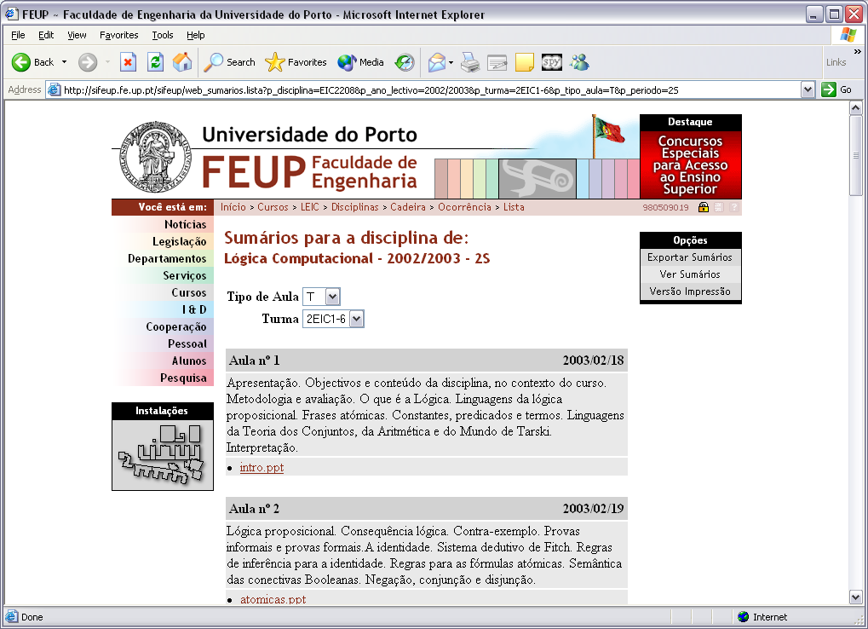

Figure 4: Summaries, as seen by students.

The impact of this module is multiple:
- Facilitates the teachers work, by offering an easy way to publish the summaries, without paper circulation, while increasing the collaboration of teams with the same course;
- Offers a single, well-known place where the students can find all the relevant information on-line, reducing the need to get hard-copies from the copy centre or from the professors themselves, and giving stronger support, mainly to those students who cannot attend every class, may be because they are also working;
- Enables reuse of information from previous editions and keeps the whole history, relieving the teachers from maintaining a course Web site (which is still possible, especially if other materials are available like lab simulations or on-line examinations);
- As it promotes the inclusion of support materials, it can be seen as the first step towards a digital archive of e-learning resources, which may be connected with e-learning platforms;
- By organizing and concentrating detailed information on each course, it facilitates the coordination among different courses and helps the students when choosing optional courses;
- Facilitates the verification role of the staff, which must check all the information is complete, and can be used as a presence control mechanism for teachers.
However, new functionalities sometimes create new needs. In addition to summaries, other pieces of unstructured documents like paper abstracts and full-texts, course syllabus, project reports, news and regulations are already in the system. The navigation plus forms search method is not appropriate for them and thus a generic textual search facility is required.
The next sections of the paper describe the development of such a search facility, how the limitations put to indexing dynamic Web pages were circumvented, and an evaluation of the results obtained.
3 Static versus dynamic Web pages
The revolution brought by the Web to the information world is not as much due to the huge volume of information at everyone’s disposal as to the dramatic increase on the information access efficiency that made possible previously unfeasible tasks [13].
Among the key tools in this context are the Web search engines. They evolved from an idea as simple as the model of the Web: the Web is a network of Web servers, each one responsible for a collection of cross-linked HTML pages (see Fig. 5). The search engine includes a crawler that, starting at a given URL, retrieves the corresponding page and recursively follows its links to other pages. Then it indexes the full text of the page, along with its URL. Afterwards, it becomes able to answer requests on information related to specified words by returning the URLs of the pages containing them. Thus, the search engine can be seen as made of three components: the crawler, the indexer, and the query processor. Many developments of this basic idea have been produced in order to improve the relevance factor of each page and the precision and recall metrics of the search [11], for instance, counting the number of occurrences of each word in the page, assigning more weight to occurrences in headings or in META tags, combining with other methods of classification, etc.
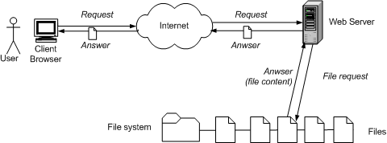

Figure 5: Answering a static page request.

However, as seen in the previous sections, the Web contains more than collections of HTML pages. Information systems (IS) like SiFEUP contain large amounts of information which is typically more structured than the texts in HTML files and is organized in database systems with their own linking mechanisms. Current IS are accessible via interfaces that adopted the Web paradigm and technology. The end-user just requires a Web browser to navigate through the pages of the corresponding sites. The main difference is that these pages no longer correspond to a HTML file stored in a file system but are instead generated, upon a user request, by specific programs that gather the information needed from the database and deliver the HTML page directly to the user (see Fig. 6). These pages are called dynamic pages in data intensive sites [14] as opposed to the static pages frozen in HTML files.
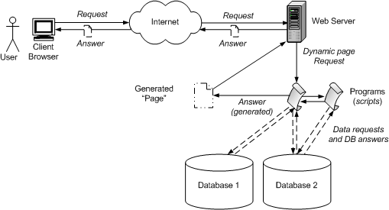

Figure 6: Answering a dynamic page request.

There are a number of advantages of this approach. The quality of the information presented directly benefits from the ability of DB systems to organize, maintain consistency, update and control the access to information. Generating the page at request-time enables a more flexible presentation of information, through the specification of several search criteria, and even to personalize it, if the user is known to the system.
The user is probably not aware of these technical issues and sees the site as a set of linked pages irrespective of their source, real or “virtual” files. So, the user expects a search facility that answers a set of relevant pages to a query involving one or more terms. This goal of uniformly dealing with static and dynamic sites is especially relevant in mixed sites combining structured data with non-structured text like SiFEUP.
Unfortunately, dynamic Web sites raise several difficult problems to the search engines.
4 Why Search Engines Fail in Dynamic Web Sites
Before the discussion of the above mentioned difficulties, there is a more detailed comparison with the usual way of querying an IS with a Web interface.
In simple sites, navigation may be almost non-existent and the interface to the DB may be as obvious as a series of forms where the user types the search criteria receiving as an answer a page with a table containing the records which have been retrieved by the DB query processor. In some systems it is even possible to write down an SQL query.
The main problems with the forms-based approach are:
- the forms to be used must be anticipated by developers, trying to match the typical user requests but leaving out more specific needs;
- in a DB, the information is stored in different tables and columns and retrieval must specify which one is to be used, but users don’t like to choose fields before the search [18];
- the search requires exact-match and the SQL to simulate a generic search (including stemming and the stripping of capitalization and accents) becomes rather cluttered and complex [1];
- all the records satisfying the search criteria are retrieved with equal importance and ordered by column contents, but the relevance of the items in the answer are different and acknowledging this is crucial when large numbers of records are retrieved [18].
Not everything is bad with the forms-based query with respect to the full-text indexing:
- DB indexing is usually done in real-time, while in the other case it is deferred and thus require periodic update;
- the DB needs less computing resources (CPU and storage) than the search engine;
- the output sorting method can be specified, while in the search engine is usually fixed to be the decreasing relevance order.
In more worked interfaces, the tabular nature of the system is much more distant from the user eyes, and the page includes significant pieces of text and data collected from several DB tables, creating something closer to a document than to a DB extract.
A generic search facility is expected to retrieve these documents and not lists of records from the DB. The combination of the Web and DB technologies produce highly mutable pages which may be different depending on the user and on the moment of the request. So, the very notion of document must be revised. In this paper, if to similar requests the system answers pages with different contents because the user is different, they are considered different documents. If the difference is only due to changes in the DB between the requests, these are considered different versions of the same document.
Therefore a generic search mechanism is justified. However, typical search engines, which were designed for static contents, do not index dynamic Web pages or just do that for those that are specifically linked from a static page and do not follow on the links the dynamic page may contain. Indexing and searching dynamic pages raises several extra difficulties not solved by most search engines [4,13,14]:
- the number of URLs of dynamic pages in a site may be infinite due, for example, to the use of a session number as an entry parameter in the URL, which changes on each request, despite the actual contents remaining the same;
- there is the possibility of falling into an infinite loop of page generation not easy to detect;
- many dynamic pages are not directly accessible from a link in another page but only as a result of the submission of a form filled in with appropriate values, but allowing the crawler to submit a form is questionable because it is not easy to know which values to choose (the number of combinations may be infinite) and sometimes to submit a form causes a change in the DB, something a crawler is not supposed to do;
- the inherent dynamics of these pages leads to indexes built by the search engine that become outdated at a fast pace;
- in sites with access control, the crawlers are assigned a general public status, reducing the interest of the engine to the qualified user;
- it is hard to decide on index refresh policies due to the absence or variability of last change date.
In conclusion, a significant number of the pages that a user may be interested in are not indexed by most search engines. They constitute part of what is called the Invisible or Hidden Web [2,5,6,10,12,19], along with, for instance, the pages that have no access path to them.
5 Contribution to Reducing the Invisible Web
Among the techniques to overcome some of the barriers listed in the last section one is the analysis of the Web forms that the crawler goes into, looking for input fields with associated lists of values which may be repeatedly used in automatic submissions of that form, in order to collect the maximum number of result pages [3,15,16,17,20].
Going much further requires the use of meta-information about the DB. This is the approach followed in this paper because the motivating case study problem is a local organizational Web IS. Therefore, there is knowledge about the DB schema and access to the DB contents, which can be used by the search engine. This situation is common to other intranet IS. The solution described in this section proposes an architecture where the inside information needed is clearly identified and localized.
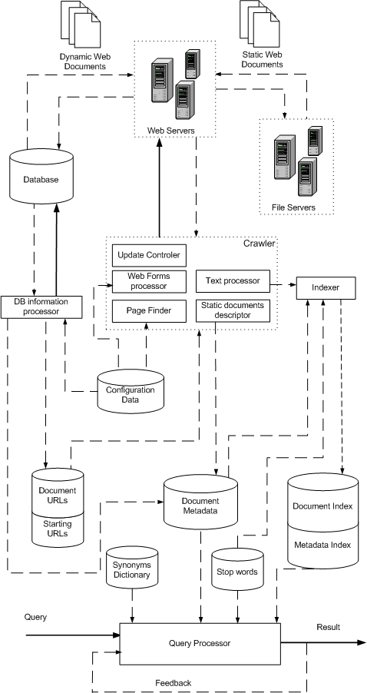

Figure 7: System architecture.

The proposed search engine (see Fig. 7) includes the usual components (the crawler, the indexer, and the query processor) plus a DB information processor, which concentrates the DB specific knowledge required to improve the recall.
The crawler is a complex component accomplishing several tasks. The Page Finder is in charge of following the links and does that with no other concern as not to go outside the target IP domain. As opposite to many crawlers, it accepts URL parameters and insists on following every link to any depth, leading both to dynamic and static pages. The target domain and exceptional URLs that must not be followed are stored in the Configuration Data. The starting points are stored in the Starting URL list. The links found in the processing of a document are queued in the Documents URL list, for a later visit.
The ideas behind dealing with forms are: values in hidden fields of a form, normally used to forward previously collected data, are kept as they are and used in the automatic submission of the form; the other fields are filled in with the default values, if any, or taken to be null. Combinations of possible values present in combo-boxes and radio buttons are not currently used as, in SiFEUP, they would mean to obtain a subset of the default answer. The Form Processor will apply this technique to the forms classified as able to be followed by a meta-tag in the page itself. This is an example of establishing some rules for the development of new modules in the IS.
The Update Controller uses HTTP information (If-changed-since tag) to recognize a change in a static document, and the information given by the DB Information Processor for the dynamic pages.
The Static Page Descriptor gets metadata about the static pages. The metadata relative to the dynamic pages comes from the DB Information Processor as well. This information is stored in the Document Metadata table. Among other data, the size of the document is available.
The last module in the Crawler component is the Text Processor. It cleans up the text, for instance stripping HTML tags, and converts from different file formats like MS Office, PDF, etc.
The other modules have been specifically developed for this project. However, for the Text Processor and the Indexer, an Oracle Tool called Oracle Text has been used, and properly configured.
The Indexer builds two inverted file indexes whose entries are the words appearing respectively in the document and in the metadata (Document Metadata), except for the stop-words listed in the corresponding table.
The Query Processor is the third component. It receives a user query, may change it using the synonyms dictionary and the stop words, and consults the indexes to build the result, according to the relevance information of the pages.
To calculate the relevance factor the starting point is the value given by Oracle Text, modified to account for the importance of the page in its environment, i. e., giving more relevance to the pages based on tables which are central and possess more relationships going into them.
To complete the description of the system developed, the DB Information Processor gets metadata about the dynamic pages, including criteria to support the refreshing policy and improving the pages relevance factor. It also deals directly with DB columns that are known, in the Configuration Data, to contain URLs, like the links to the teacher or the student non-official pages.
As the RDBMS used by SiFEUP is Oracle, the language chosen for the development has been PL/SQL. The tests performed with the system indexed about 140 000 pages, both dynamic and static, including non HTML documents. The answers to queries varied from negligible to 10 seconds, with a typical value around 3 seconds.

Figure 8: Search results.

The analysis of the graphic in Fig. 8 shows that some queries produce large quantities of documents. They correspond to specifying a common single term query. This is not a bad result from the viewpoint of finding the appropriate documents, because the more relevant are shown first. However, it implies a longer computation time while the user is waiting. Fortunately, most queries lie on the left side of the graphic meaning shorter and, most of the time, faster answers to 3-4 term query.
6 Conclusion
Current IS are subject of an apparent contradiction. On one hand they are built on top of databases storing highly structured information. On the other hand, the presentation of this information is done via Web interfaces made of HTML pages, usually not structured. The bridge between the DB and the user is made by dynamic Web sites, in the organizational intranet which is, sometimes, accessible by the whole Internet. Using complementary information from the RDBMS relationships in the pages generated from that data, a better recall figure is obtained.
The main conclusion is that adding to the IS the generic textual search composed with metadata from the DB improves the access to information, with respect to the traditional method based on menus, hyperlinks and Web forms, especially for the occasional users. It has been noticed that, even for regular users, it increases the visibility of certain contents in the periphery of the system.
The criteria followed in modifying the relevance factor, though always subjective, proved to bring to the first rows the kinds of pages the user expects. For example, asking for a person’s name retrieves, most of the times, the corresponding official personal page. This happens because those pages are central in the system. Sometimes, the first row is the bibliographic page of that person, as it contains multiple occurrences of the name as the author of the different publications. Finding the desirable weight factors requires a careful trade-off.
The results of the interaction with an Information Retrieval system are of a different nature from those obtained from a database. When querying a DB, the answer given to the user is a record set corresponding, in a deterministic and objective way, to the query, irrespective of the DBMS used. In an interaction with an Information Retrieval system, the answers are less determined by the query, though some level of relationship always exists. Determinism in these searches is derived more from the nature of the document pre-processing techniques like index construction and clustering, and query interpretation, than from the structure of the information. Different systems typically produce results not fully coincident.
References
[1] Eve Andersson, Philip Greenspun, Andrew Grumet. “Internet Application Workbook”, (2001). http://philip.greenspun.com/internet-application-workbook/. 21-12-2002
[2] Joe Barker. “Invisible Web: What it is, Why it exists, How to find it, and Its inherent ambiguity”, (2002). http://www.lib.berkeley.edu/TeachingLib/Guides/Internet/InvisibleWeb.html. 20-12-2002.
[3] Michael Benedikt, Juliana Freire, Patrice Godefroid. “VeriWeb: Automatically Testing Dynamic Web Sites”, Proceedings of the 2002 WWW conference, Honolulu, Hawaii, USA, (2002). http://www2002.org/CDROM/alternate/654/ 22-12-2002.
[4] Michael K. Bergman. “The Deep Web: Surfacing Hidden Value”, The Journal of Electronic Publishing, 7, no. 1, (2001). http://www.press.umich.edu/jep/07-01/bergman.html. 20-12-2002, http://www.brightplanet.com/deepcontent/tutorials/DeepWeb/. 20-12-1002.
[5] Diana Botluk. “Exposing the Invisible Web”, LLRX, no. October 1999, (1999). http://www.llrx.com/columns/exposing.htm. 21-12-2002.
[6] Anne Clyde. “The Invisible Web”, Teacher Librarian, 29, no. 4 (2002). http://www.teacherlibrarian.com/pages/infotech29_4.html. 20-12-2002.
[7] Gabriel David, Lígia Maria Ribeiro. “Getting Management Support from an University Information System”, Proceedings of the European Cooperation in Higher Education Information Systems, EUNIS99, Espoo, Finland, (1999). http://sifeup.fe.up.pt/sifeup/WEB_BIB$PESQUISA.download?p_file=F6934/Eunis99sent.doc. 19-12-2002.
[8] Gabriel David, Lígia Maria Ribeiro. “Impact of the Information System on the Pedagogical Process”, 7th International Conference of European University Information Systems, EUNIS 2001, Berlin, Germany, (2001). http://sifeup.fe.up.pt/sifeup/WEB_BIB$PESQUISA.download?p_file=F14804/eunis2001_b_final.doc. 19-12-2002.
[9] P. Fraternali. “Tools and approaches for developing data-intensive {Web} applications: a survey”, ACM Computing Surveys, 31, no. 3, pp. 227-263, (1999). http://www.ucsd.edu/cse132B/WSMT.pdf. 20-12-2002.
[10] Karen Hartman, Ernest Ackermann. “The Invisible Web”, a presentation at Computers in Libraries 2000, (2000). http://www.webliminal.com/essentialweb/invisible.html. 20-12-2002
[11] Karen Spark Jones, Peter Willett. “Overall Introduction”. In Karen Spark Jones, Peter Willett (eds.). Readings in Information Retrieval, Morgan Kaufmann, pp. 1-7 (1997).
[12] Robert J. Lackie. “Those Dark Hiding Places: The Invisible Web Revealed”, (2001). http://library.rider.edu/scholarly/rlackie/Invisible/Inv_Web.html. 20-12-2002.
[13] Steve Lawrence, C. Lee Giles. “Accessibility of Information on the Web”, Nature, 400, no. July 1999, pp. 107-109, (1999).
[14] Steve Lawrence, C. Lee Giles. “Searching the World Wide Web”, Science, 280, no. 5360, pp. 98-100 (1998). http://www.neci.nec.com/~lawrence/science98.html. 9-12-2002.
[15] Stephen W. Liddle, David W. Embley, Del T.Scott, Sai Ho Yau. “Extracting Data Behind Web Forms”, Proceedings of the 28th VLDB Conference, Hong Kong, China, (2002). http://www.deg.byu.edu/papers/vldb02.pdf. 20-12-2002.
[16] Stephen W. Liddle, Sai Ho Yau, David W. Embley. “On the Automatic Extraction of Data from the Hidden Web”, Proceedings of the International Workshop on Data Semantics in Web Information Systems (DASWIS-2001), Yokohama, Japan, (2001). http://www.deg.byu.edu/papers/daswis01.pdf. 22-12-2002.
[17] Sriram Raghavan, Hector Garcia-Molina. “Crawling the Hidden Web”, Technical Report, Computer Science Department, Stanford University, (2000). 2000-36. http://dbpubs.stanford.edu/pub/2000-36. 22-12-2002.
[18] Avi Rappoport. “Search Engines: The Hunt is on”. (2000). http://www.networkcomputing.com/1120/1120f1.html. 02-07-2002.
[19] Chris Sherman, Gary Price. “The Invisible Web: Finding Hidden Internet Resources Search Engines Can't See”, Independent Publishers Group, (2001).
[20] Sai Ho Yau. “Automating the Extraction of Data Behind Web Forms”. Masters Thesis, (2001). http://www.deg.byu.edu/papers/TonyYauThesis.doc. 22-12-2002.

This is distinguished from pages that incorporate Dynamic HTML or JavaScript to get animation effects but are nevertheless defined beforehand in a static file.

