Title: How the FEUP Removal to the New Premises Was Facilitated by the Internal Information System
Author: Lígia M. Ribeiro, Maria Antónia Carravilla and Gabriel David
Organization: Faculdade de Engenharia da Universidade do Porto
Email: lmr@fe.up.pt, mac@fe.up.pt, gtd@fe.up.pt
Address: Rua Dr. Roberto Frias s/n 4200-465 Porto, Portugal
Url: http://www.fe.up.pt
Keyword: Information Systems, FEUP, SiFEUP, Changing procedures
Abstract
Since 1996 that FEUP possesses an information system (SiFEUP) that was developed mainly to record the information on the school’s activity concerning teaching and learning, research and development as well as for school management.
The system has been built in-house and has nowadays more than 30 integrated modules that are enabling the modernization of many processes and services providing simultaneously decision support facilities.
In this work we will show how this system was a key tool to organise the logistics of the Faculty removal to new premises, namely its importance for minimizing the impact on the users resulting from the change to completely new infrastructures.

Presentation of the Engineering Faculty and its environment
Descending from the Polytechnic Academy, created in 1837, the Faculty of Engineering of the University of Porto (FEUP) is presently a prestigious public institution concerning the teaching and research of Engineering.
The Engineering Faculty is the biggest of all the faculties that belong to the Porto University. It has almost six thousand students, four hundred professors, more than a half with a PhD, and two hundred staff. The University of Porto, is itself the biggest in Portugal, with approximately 25 000 students.
FEUP presents a departmental structure, composed of six areas, Civil Engineering, Chemical Engineering, Electrical Engineering and Computers, Mechanical Engineering and Industrial Management, Mining Engineering, Metallurgical Engineering and Materials. To support the activities of these departments and of the Faculty as a whole there are several central services, including the Computer Centre, the Library, the Academic and Staff, the Economic and Financial, the Continuous Education and Development, the Public Relations and Image and the Technical and Maintenance Support services.
FEUP offers eight undergraduate courses, 23 MSc degree courses and 8 areas for PhD studies, as well as other specialized post-graduate courses.
Besides teaching the FEUP is currently involved in more than a hundred research projects, many of these on an international basis and in co-operation with industry.
Since the year 1937 until September 2000, the Engineering Faculty occupied a location in the centre of the Porto city, with around 30 000 m², where several adapted buildings housed the departments, services and R&D institutes.
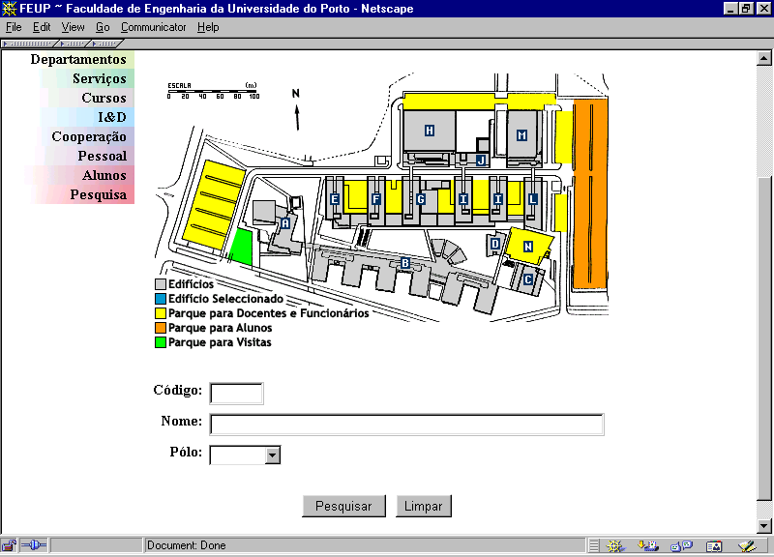
Figure 1. SiFEUP: information about the Faculty map

On September 2000, the Faculty moved to a new location, in the city periphery. This new location almost triplicates the available area. The different departments and services occupy 12 main buildings, as shown in Figure 1. The covered area is now about 90.000 m², where lecture rooms and offices occupy each 17.000 m² and laboratories 41.300 m². This was probably the biggest and most complex move that occurred in town for many years.
One of the many aspects of the move that has been particularly demanding was the maintenance of the users connectivity to the network and computing services. Since 1988 the Engineering Faculty possesses a local data network. It has been built as a shared 10Mbps Ethernet network and upgraded to a switched 10Mbps Ethernet technology in 1995. Just before the removal to the new premises the number of nodes connected to this infrastructure was around 2 500. In the new location, the local area network is a completely different infrastructure incorporating ATM OC-12/OC-3 technology, respectively in the core and in the backbone, and offering switched 100BASE-TX to the users, at the access level. If necessary, it can also offer ATM to designated users. The number of active access points is this infrastructure is 6000 and about 3500 nodes are presently connected. These nodes comprise central clusters of UNIX/Linux and NT servers, plus several departmental NT and Linux servers, and more than 500 microcomputers in 30 general computer labs. The library has also about 100 desktop computers for the students and many others are available at the departmental laboratories. The ratio student/computer is better than 5. The FEUP LAN, that we call FEUPNet, is connected to the national scientific communication network (RCTS) by a 2Mbps link.
The Faculty always promoted the use of the computing environment. All the students are allowed to use the network and computing resources since the first year of their undergraduate programmes. They also have full access to the Internet, as well as all the other elements of the academic community. Almost every professor, technician or administrative staffs has a personal computer connected to the FEUPNet. FEUP offers teleworking facilities and presently near 2000 students and staff use traditional analogue telephone lines and ISDN to connect to the FEUP Access Server and access the resources available to do remote work.
As the network and its computing and information resources are used on a daily basis, it was necessary to guarantee the users connectivity to the main services during the removal period and no more than a 24h interruption was acceptable. Because the removal of the Faculty was scheduled to occur in less than two months, the connectivity to the network and access to the servers should be available to the users that were already at the new premises as well as to the users that were waiting to move, at the old buildings.
We will show in this work that the internal Information System (SiFEUP) has been a key factor to make the removal of the whole Faculty feasible in an especially short interval. It helped on minimizing the impact on the users and permitted the new academic year to start normally, with just two weeks of delay.
The initiative of creating an integrated campus wide information system belonged to the faculty direction board, in 1996 [1]. Its strong commitment with the project was essential to make it possible, as the different departments and R&D units within FEUP have large freedom in managing their resources and thus a high level influence is necessary to push towards the development of such a system.
The main goal of the SiFEUP has been to enable faster access and dissemination of scholar, scientific, technical and other info-resources, stimulating a stronger collaboration among members of our academic community. A second, but equally important goal, has been the possibility to increase the connection and the interaction with other higher education institutions and with industries, especially in the northern region of Portugal.
Before the removal, the information system already included about 30 modules covering aspects ranging from the school infrastructures and the academic and staff records, to the course plans, scientific productivity or the external assessment processes [2, 3].

Planning the removal

Logistics
The removal of FEUP did start 18 months ahead with the inventory of all goods that we need to move. SiFEUP took an extremely important role in this task.
During this inventory period SiFEUP databases were fed with information concerning staff and classroom furniture, lab equipment, computer and peripherals, and all kind of machines. Special attention was given to particular equipment where size, weight, fragility or release date could be relevant to the process. When needed new fields were added to the SiFEUP databases.
Nearer to the target date, FEUP direction board took the decision of celebrating three different removal contracts: books and documents, furniture and computers (special equipments were left to other kinds of contracts). At this point SiFEUP was again a priceless tool because, to launch the contracts, a survey of all removable equipments was needed. Querying the database and producing printed lists, ordered by type, size or location, to be attached to the quotation requests was done easily.
Planning the removal has thus been an easier task with SiFEUP. Clusters were defined straightforwardly so that equipments “belonging” to the same contract, placed at different locations, but with the same destination building, have been identified and planned to be removed simultaneously.

Providing contact information
The SiFEUP official information on each member of the teaching and administrative staff includes, since the beginning, his office number, main and secondary telephone numbers, e-mail address and complementary home page URL, if there is one. The first two items of this contact information are kept by the Staff Service, and the last three items by the staff member himself. It was enough to provide updated phone or e-mail directories and to help on finding someone, until the removal planning started. At that moment new requirements became priority: more than one room should be allowed for each person, and a way of publishing the blueprints of the new buildings should be found.
Actually, it was convenient to record the assignments of staff to the rooms in the new premises as soon as the decisions were taken, so mistakes could be easily spotted and the whole process become widely known and transparent. The old rooms were still active for a few months. Fortunately, the underlying database design already supported more than one room associated to each person, so a small adjustment of the user interface accomplished the task.
To fulfil the second requirement a new module has been developed which, instead of just collecting the scanned version of the architect’s blueprints, provides an interactive image of the blueprint of each floor of each building. Clicking on a room highlights it and displays its characteristics – identification, usage, area, number of intended occupants, equipment, network access points, telephone numbers. This tool proved very useful in several respects: it satisfied the natural curiosity of everyone about the details of the new buildings and improved the motivation to prepare the removal; it disseminated the nomenclature of the new spaces, overcoming divergences between different versions of printed blueprints; it helped the staff to choose the rooms among the proposed alternatives and to explore the future environment. As soon as someone got assigned to a room, contacting him became an easy task because a link to the relevant blueprint was automatically added to his official home page, as well as a link to each occupant was added to the room. The assignment of each new telephone number to a person has been automatically crosschecked with the possible numbers in the corresponding room, highlighting mistakes and incoherence of the installing company.
Another communication facility of SiFEUP that proved very handy during the whole process has been the dynamic mail [2]. This is an implicit distribution list management system that enables anyone to send a message to a group of persons selected according to a set of characteristics specified at run time in a query form. For example, it is possible to select all the members of a department, all the full professors of the faculty, everybody called Carlos, all the students in a certain course, etc., and send a message to the e-mail addresses they have recorded in their own information. The ability to straightforwardly target messages to specific audiences helped on the coordination of the process allowing to reach the intended readers without disturbing everybody else. The turnaround delay of printed communications was not compatible with the response time required by the short overall duration determined for the removal process and the frequent rescheduling required by the optimisation of the involved resources.

Availability of network and computing resources
As said before, all the users of the FEUP academic community use the network and its resources on a daily basis. The professors, among other utilizations, use the network to prepare their classes, to provide contents to help their students learning, to consult information about the students and courses performance, to communicate both with the students and colleagues and to run their applications. The administrative staff uses the SiFEUP intensively. As the information system is installed on servers on the scientific network, FEUPNet, they must have permanent access to it. Besides FEUPNet, they use the administrative network to create and modify the students and staff records, on the corresponding databases. The information in these databases is imported to the SiFEUP to make it available for all the academic community. The Library have its catalogue available on-line. Users may apply for a book or request an article using facilities associated with the OPAC. The resources the Computer Centre offers are available through the network. In general, all the Faculty Central Services use the FEUPNet for their work. Similarly the students use the FEUPNet to register for classes, to visualize their schedules, to access the information and resources about their disciplines, to communicate with the professors and with each other, to ask for certificates, to access the OPAC, to do their class work and programming and to access the intranet and Internet resources.
It was thus a fundamental goal to create conditions to maintain the accessibility of the network high for all the users during the move of the Faculty to the new location.
The Computer Centre accompanied the installation of the passive and active infrastructures of the new FEUPNet. It provided the installer information to configure all the switches at the four levels, core, backbone, distribution and access, as well as the three core routers. Private IPv4 addresses were used all over and about 50 virtual LANs were created on campus. ATM addressing was also configured.
In order to prepare the move, the Computer Centre used the SiFEUP to provide all the information concerning the configuration of a network node in each room of the new buildings (see Figure 2). For each room and for each access point (“Tomada” on Figure 2), the IP address, the gateway and a temporary logical name for the node was provided. Information about the DNS primary and secondary servers as well as for the WINS servers was also displayed, together with the subnet mask and the domain name fe.up.pt. Fixing a logical name for the nodes at the new premises, although just on a temporary basis, has been necessary to maintain all the network services in both the old place and the new one. The two places were connected by a 1Mbps-dedicated link.
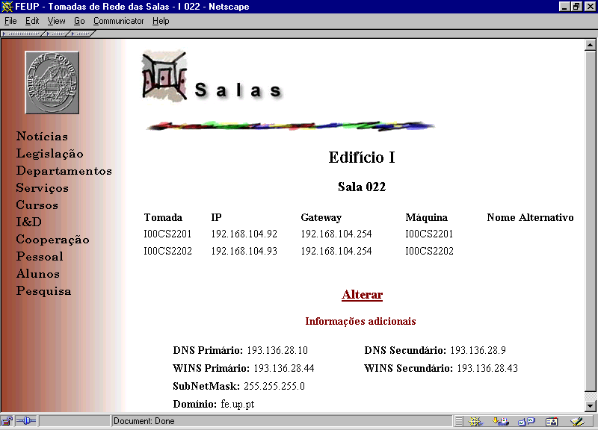
Figure 2 SiFEUP network information

Using this information, most of the users were able to configure their PCs themselves when they have moved to the new rooms. The support of the Computer Centre technical staff to this task was kept at a practical level. The configuration of nodes in the computer laboratories has been done the same way. At the old place, users maintained their connectivity to all services without the need to alter the PCs configuration.
The above methodology has been previously explained to all the academic community using the SiFEUP dynamic mail [2] facility, which allowed tailoring the explanations in accordance with the users group profile.
This way only when the Computer Centre moved the central servers to the new location the users were not able to access the network. This was done in 12h. Half a day was thus the interruption period that users suffered in spite of the complex process of such a move.
Later on, when most users were already at the new location and using the network, the SiFEUP was brought into play again to create an interactive facility for the users to choose the definitive DNS name of their nodes in the new network. Again associated with each room’s page, a “Change” (Alterar) button allows the user to suggest the logical name for the node associated with each IP address. To do this, the user must identify himself and the system verifies whether he is an authorized user for the corresponding room. After the Computer Centre has validated the suggested logical name, it is introduced in the DNS database and the user receives acknowledge by mail. As the system automatically records the user of the request, the Computer Centre may also contact him to resolve some possible DNS name conflict.

The installation
Several tasks related to the installation phase in the new building profited from the help of SiFEUP, as shown in this section.

Sizing the acquisitions and maintenance contracts
Specific data related with different rooms such as dimensions, capacity or usage was introduced in SiFEUP enabling, at the final stage, to define quantities of furniture to buy for classrooms and professor or staff offices. In addition sanitary fittings like hand dryers, toilet paper or soap dispensers have been quantified with the help of SiFEUP.
Signalling of offices, laboratories, classrooms and buildings was also done making use of information supplied by SiFEUP.
Launching of cleaning or security contracts was again based on data supplied by SiFEUP. It helped to know quantities of toilets and square meters of offices and corridors or to define day and night rounds for the watchmen and the best placement for video cameras.

Start-up of the new academic year
Moving to the new premises was not just a matter of transporting assets and reproducing the old routines. The dramatic change in the facilities induced the setup of new procedures plainly not feasible in the old conditions or that the management decided to implement profiting from the dynamic of the whole process. This required an extra effort from the SiFEUP team and at the same time increased the role of the system in new areas.
Before, class timetables were the responsibility of each course director who had a set of classrooms to manage, with the inherent waste of resources. Currently, the course director is still providing the first draft of the timetable but the actual classrooms are centrally assigned using a single database and its usage is thus globally optimised. A similar procedure is adopted to schedule the examinations among the available examination rooms.
The same room database is used to support the Web-based booking of rooms for specific events like conferences, special examinations, meetings, etc. The size of the facilities and the number of events justify the need for the automation of this process. The actual booking requires confirmation but the request is not even issued if the room is not free and that can be checked in SiFEUP beforehand. The same Resource Booking Module is used to reserve equipment like video projectors, laptops, special printers, etc., but the policy here does not require confirmation before becoming effective.
A last example of using the SiFEUP in an unforeseen way is the Parking Card Module. Two weeks after the classes had started, it became clear that some discipline had to be imposed in the parking areas and that process required a parking card to be issued to each student. Readily, a Web form has been prepared that each student needing a parking card had to fill in, after authentication by the SiFEUP, in order to obtain the corresponding card number. This way, a lengthy registration process has been avoided and the whole data was consolidated.

Conclusions
The SiFEUP had a fundamental role in the removal of FEUP to the new premises. To plan the removal, several activities were carried out. The IS helped mainly on recording the Faculty patrimony associated to the respective rooms. This allowed an easy crosscheck with the persons in charge and was the base for calculating the required resources and for scheduling the whole operation.
Simultaneously, the availability in the IS of the new buildings drawings, identifying the type of each room, its capacity, and assignment to department or service, helped to organise the redistribution of the staff and the deliver of the removal boxes.
Another fundamental role was the access to the information concerning the computer network, which minimised the impact on the users resulting from the change to a completely new infrastructure. Associated with the page of each room the information on how to configure a PC on the new network was given and thus most of the users were able to do this task by themselves. A minimum support from the Computer Centre technical staff was needed. Besides this same page provides an interactive facility for users, once at the new location, to request definitive DNS names for their computers. The performance of this Computer Centre service was thus significantly improved.
The communication function of the IS was identically relevant for other aspects of the installation in the new spaces, namely on providing contact information for staff and room locations for students. Even the semester timetables were readily built with the help of the system.
The SiFEUP does already play an important role in the daily work of the Faculty, inducing new practices and facilitating processes. However new modules are under development so that SiFEUP may widen its influence enabling, for example, our staff to perform efficient preventive maintenance to the installations.
Bibliography
[1] Ribeiro, L. M.; David, G.; Azevedo, A.; Marques dos Santos, J. C; Developing an Information System at the Engineering Faculty of Porto University, Proceedings of the European Cooperation in Higher Education Information Systems, EUNIS97, Grenoble, France, 9-11 September 1997.
[2] Ribeiro, L. M; David, G.; Using an Intranet for Effective Communication, Proceedings of the European Cooperation in Higher Education Information Systems, EUNIS98, Czech Republic, 21 - 22 September, Prague 1998.
[3] David, G.; Ribeiro, L. M.; Getting Management Support from an University Information System, Proceedings of the European Cooperation in Higher Education Information Systems, EUNIS99, Espoo, Finland, 7 – 9 June, 1999.

